Creating APA Citations

Note: It is never okay to copy information from the Internet and paste it into something that you turn in as if it is your own work. Unless you are putting quotes around it, you need to put it in your own words and you ALWAYS need to cite the source.

Son of Citation Machine
http://citationmachine.net/

In the field of education, APA format is always used for citations.
(Other disciplines use other citation formats.)

Section A: How to use the Son of Citation Machine
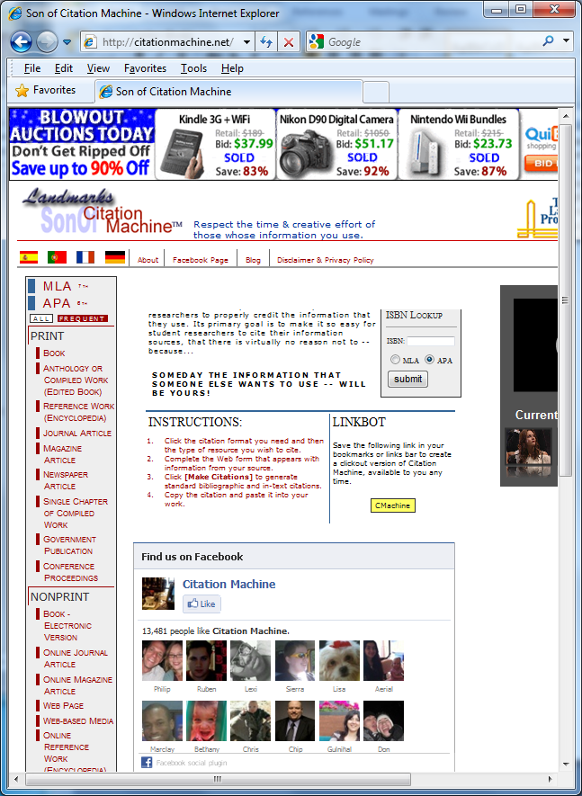
An example is outlined below…
- Choose the APA button.
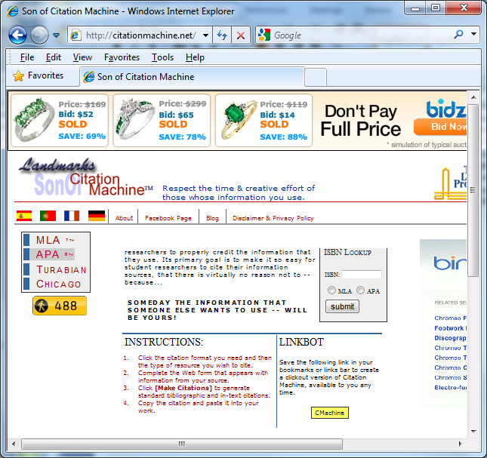

On the left side of the next screen you will find a section for PRINT citations *and* a section for NONPRINT citations. If you are citing something from the Internet, you will use the NONPRINT section.
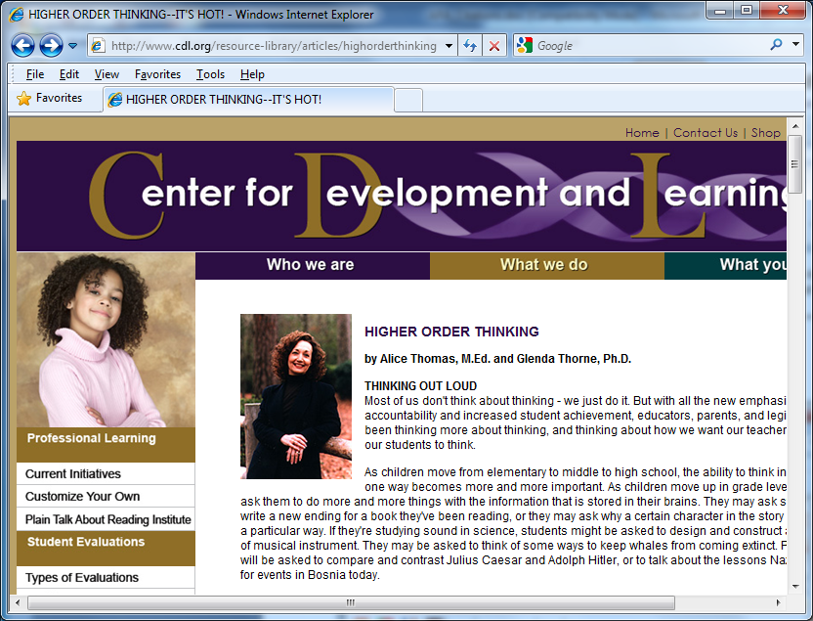

For example, to cite an article at:
http://www.cdl.org/resource-library/articles/highorderthinking.php

Since this is an online, resource, look in the NONPRINT area.
Next, look through the options and identify what “type” of NONPRINT source this is.

You will have to determine this for each instance, every time you cite an online source.

This particular example is an article, so I look to see if it is a journal or magazine with volume and issue numbers.
This example is NOT a journal or magazine, and it also does NOT fit most of the other NONPRINT categories, such as being an encyclopedia or a university document.

This article is on an organization’s information page, so for this example, the appropriate choice is “webpage.”

- For the example of *this* article you would click on the WEB PAGE link.

NOTE: A web page like this is NOT considered to be a valid educational resource for research, so the APA guidelines do not completely address it.
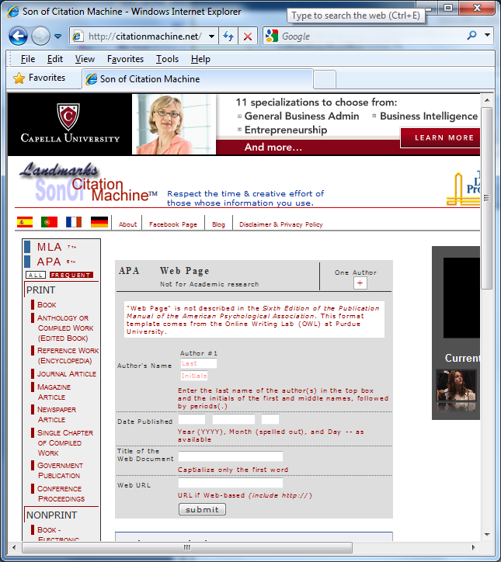
The next form has a disclaimer at the top, which reads,
"Web Page" is not described in the Sixth Edition of the Publication Manual of the American Psychological Association. This format template comes from the Online Writing Lab (OWL) at Purdue University.
- This article has two authors, so you would click the plus sign under the words “One Author” to add another author.
- For the “Date Published,” use the date you accessed (visited) the website.
- Fill out the rest of the form as instructed, and click “submit.”

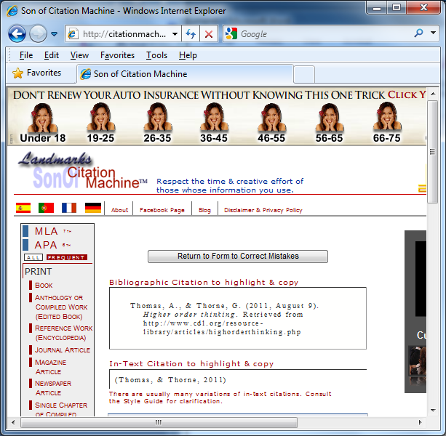
- After the submission, the next screen will preview the citation.
Son of Citation Machine put all the parts in the right order and added necessary formatting such as italics and indents.
You can go back and correct any mistakes if necessary.
If you need no corrections, you can copy the citation.

- *Notice that the citation has a specific kind of indent. This is called a “hanging indent” and is part of the APA format. It is necessary to keep the formatting.

I have copied the text from the webpage and pasted it below:

Thomas, A., & Thorne, G. (2011, August 9). Higher order thinking. Retrieved from http://www.cdl.org/resource-library/articles/highorderthinking.php

*Notice that the indented format (the hanging indent) “fell off” in the pasting process.
If this happens, you need to fix it. (See next page for instructions on creating a hanging indent.)

Section B: How to Create a Hanging Indent:

- In MS Word, on the View Tab, Show/Hide, check the box next to “ruler.”

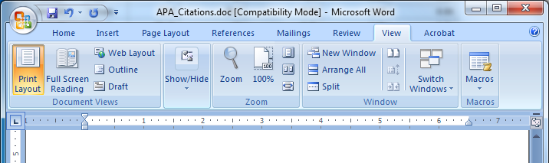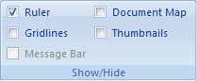

- Click and drag across the text to select it, and then adjust the bottom half of the hourglass shape by clicking and dragging it slightly to the right.

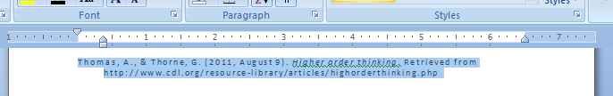

- The adjusted text (with the hanging indent) would look like this example below:

Thomas, A., & Thorne, G. (2011, August 9). Higher order thinking. Retrieved from http://www.cdl.org/resource-library/articles/highorderthinking.php

- *Notice that the typeface (lettering style) that I copied from the Website does NOT match the lettering style of my document.
- If you are putting this into a paper, you would ALSO need to make the typeface on the citation the same as the typeface in which you typed the paper.
The letter styles should match.

See below:

Thomas, A., & Thorne, G. (2011, August 9). Higher order thinking. Retrieved from http://www.cdl.org/resource-library/articles/highorderthinking.php

