**Instructions for “Social Justice Collage”   
  
Using layers to combine and arrange text and images**

1. Obtain digital images related to your social issue and save them to your computer. (minimum of five images; recommended practice is to save them into the same folder)
2. Open [http://fotoflexer.com](http://fotoflexer.com/) and click the "Upload" button.  
     
   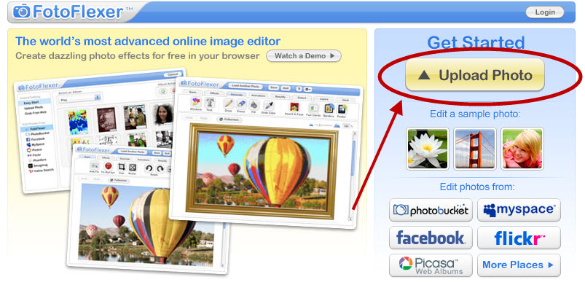

1. Upload your first photo by clicking “Upload” to select the photo to upload from your computer.  
     
   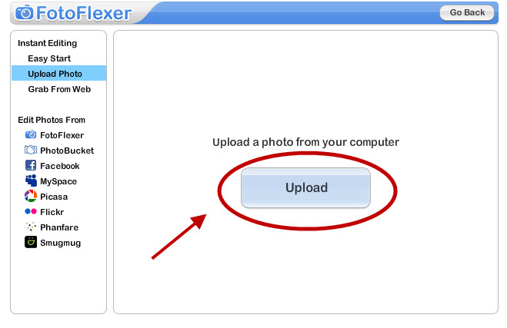
2. Select the first photo and then click “Open” to upload the photo.  
     
   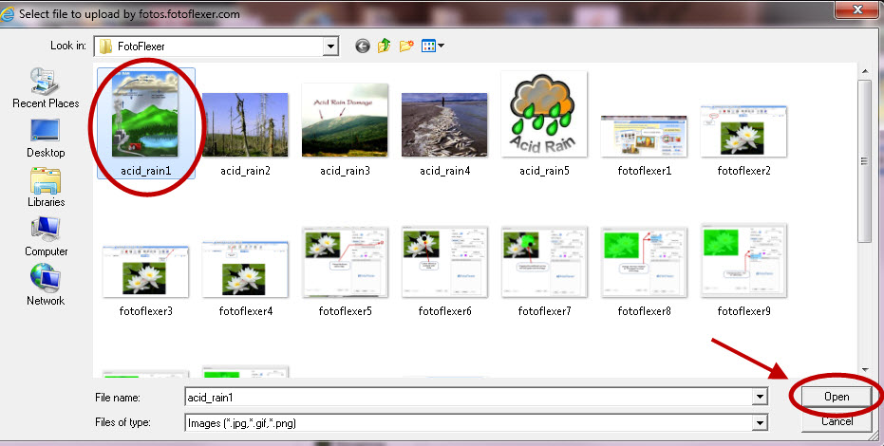
3. Click the “Layers” tab.  
     
   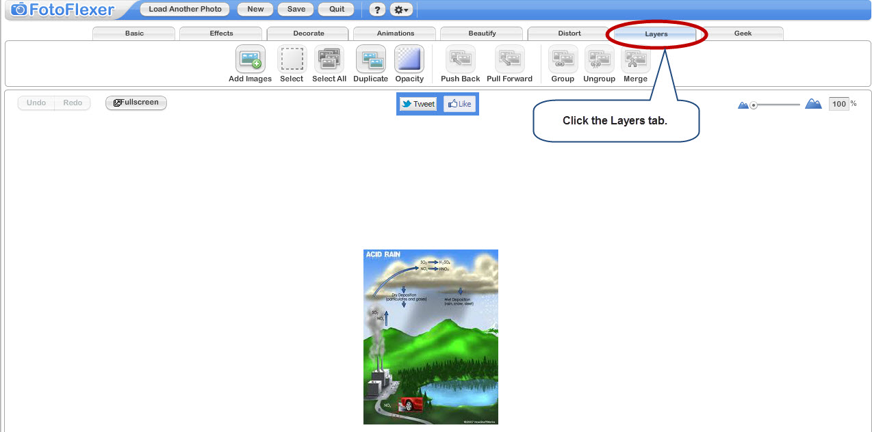

1. Click the “Add Images” button.   
     
   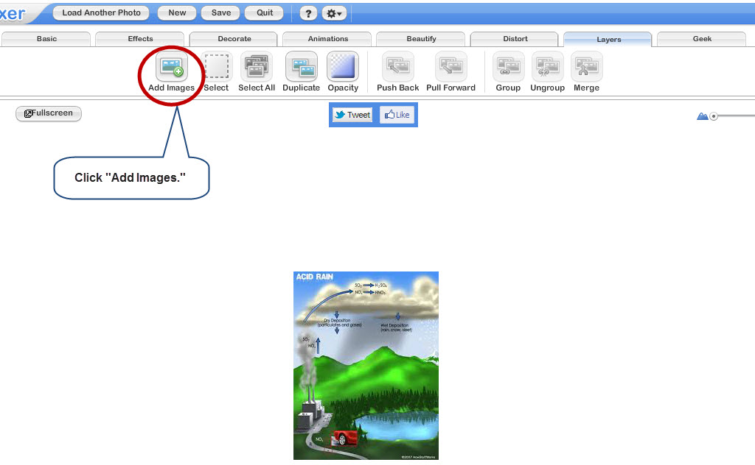
2. Repeat steps 3 and 4 to upload the 2nd image. It will appear on top of the first, with small blue boxes on the sides and corners – use these for resizing.  
     
   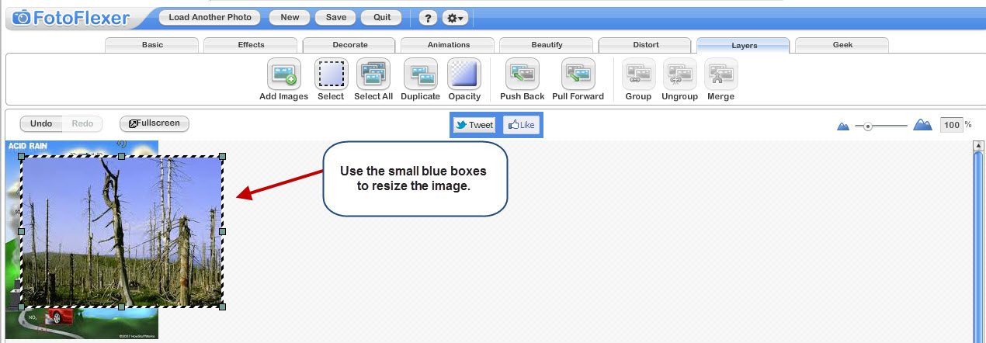
3. Click and drag either image to reposition it.  
     
   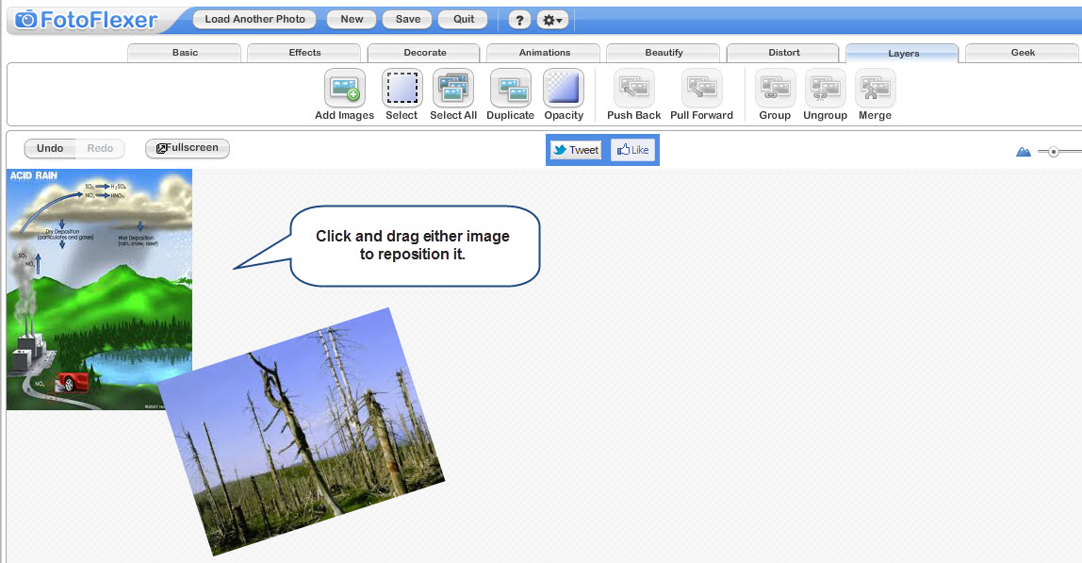
4. The large checkered area behind both of the photos is your canvas. (The area in which you can move the elements around.) This area defaults to a square. PhotoFlexer does not allow you to use the crop tool on this layered image, but if you only use the top half of the canvas, when you save it, it will discard the lower half.
5. Add more images by repeating steps 3 and 4, and experiment with resizing and moving the images. Overlapping is desirable. Avoid obvious symmetry.  
     
   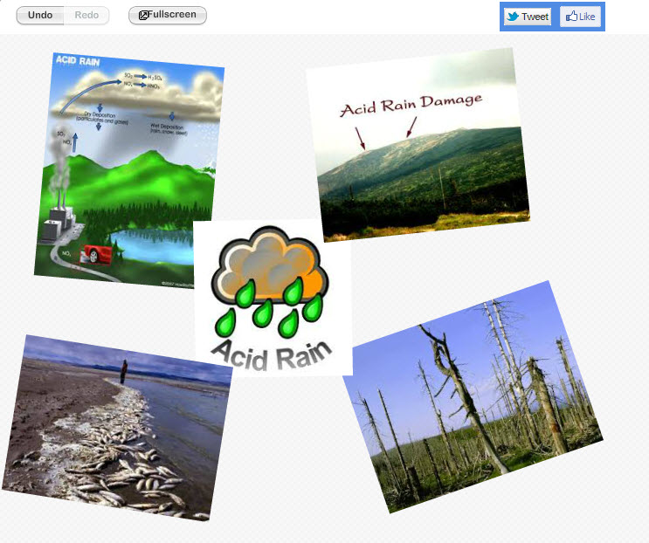
6. Add text by clicking on the “Decorate” tab, and then on the “Text” Tool.  
     
   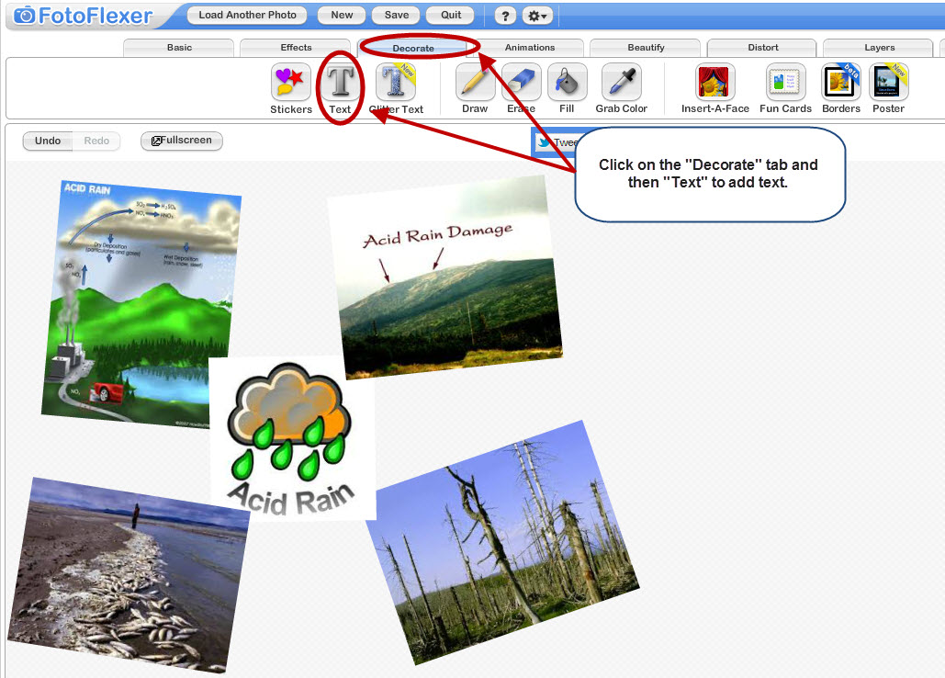
7. Enter your first word in the “Enter Text Here” box. As you enter your text it will appear in another box on the screen. You can move and resize the text using the blue boxes around the text. (You must have at least 3 different words.)  
     
   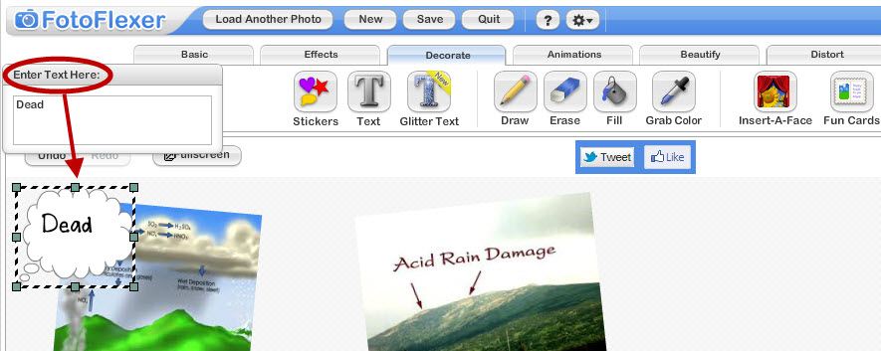
8. At the right-hand side of the screen, a dialog box for “Text Options” has appeared.  
   Experiment with fonts, sizes, and placement. Text overlapping the images is desirable.  
     
   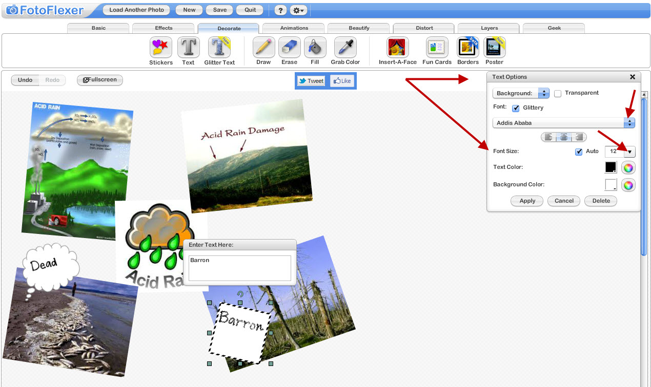
9. Click the box next to the word “Transparent” so that your images will show through the text box.  
     
   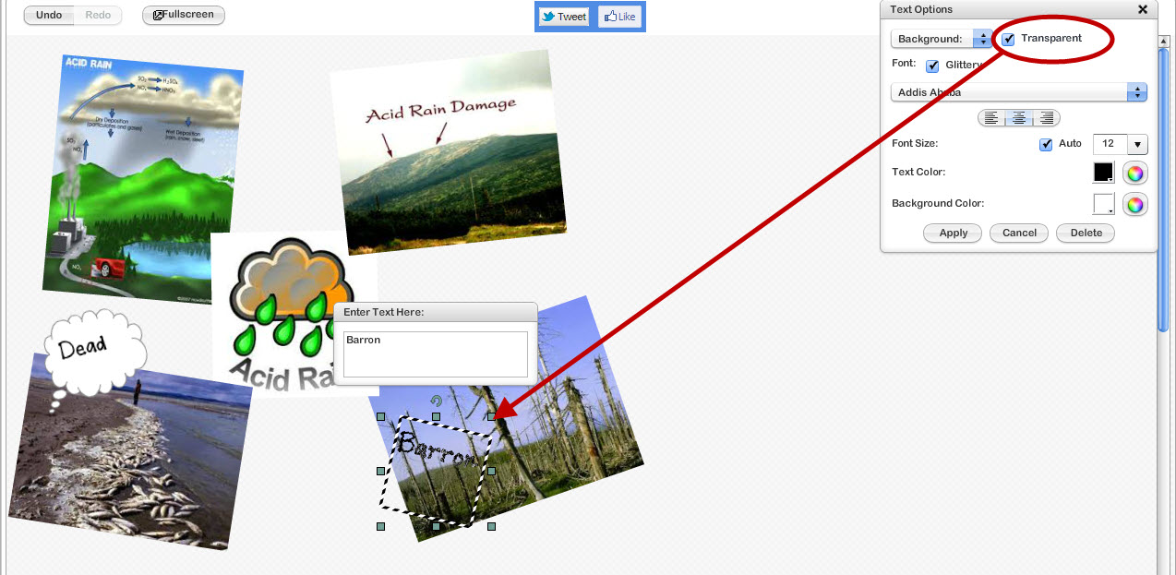
10. Click “Apply.” The layers are still moveable, and changes can continue to be made.  
      
    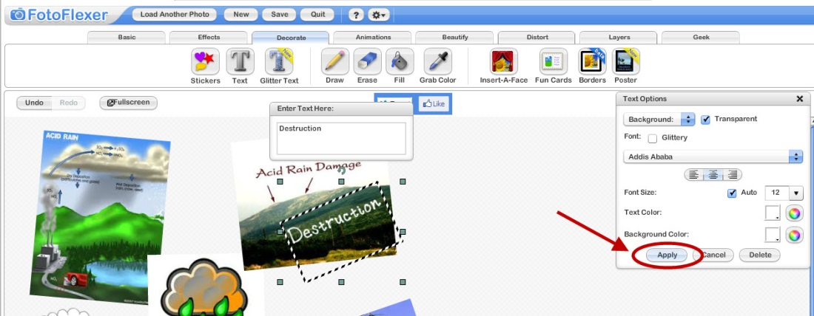
11. You can add more photos or more text boxes as before.
12. This image will need be re-sized, but FotoFlexer will not do it from the layers section.  
    You must first save it (download it) to your computer (as you did for the digital self- image). You can choose JPG format OR you can choose PNG (which will preserve the transparent areas).
13. Upload the image back into FotoFlexer. Resize the photo so that the LONGEST side (whether it’s the height OR the width) is no larger than 250 pixels. To resize click the Resize button on the menu bar under the basic tab, change the pixels for either height or width by typing in a new pixel number or using the slider bars under height or width. You only need to change one as the other number will adjust automatically.   
      
    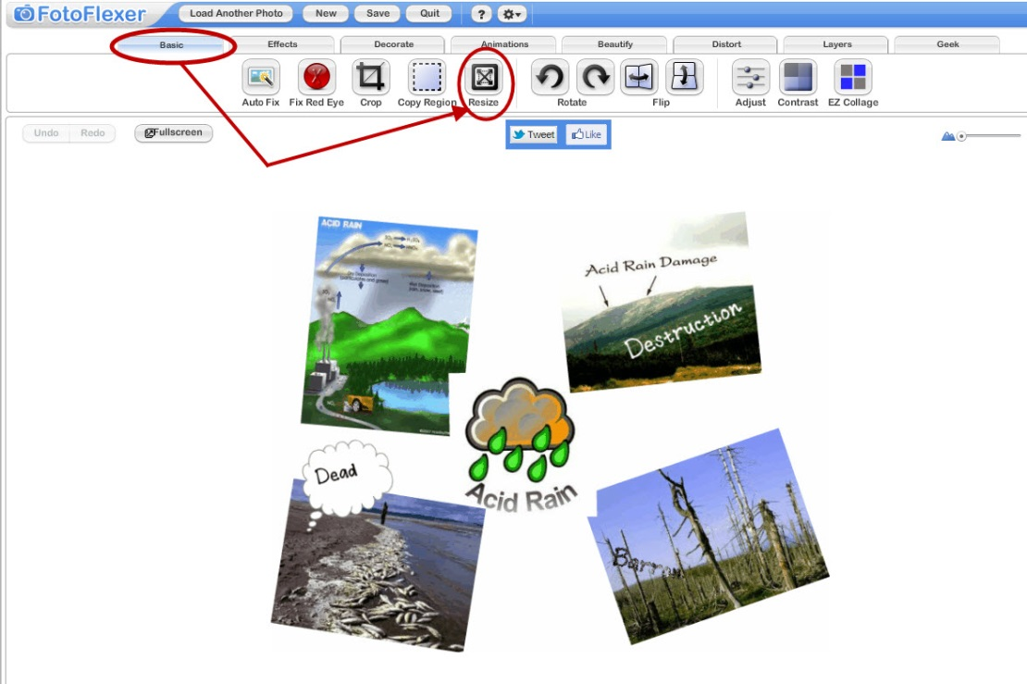
14. Click Apply.  
      
      
    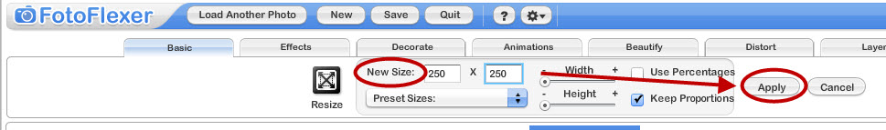
15. Save the resized image to your computer. This resized image is the one for submission.