**How to create a blank (single color) image online at** [**www.fotoflexer.com**](http://www.fotoflexer.com)

You first need an image then you can change it into a single color image.

1. At the FotoFlexer home page, click on and select one of the sample photos, such as the white flower at the right. (You do not need a “login.”)  
     
   
2. Once the photo loads, click on the tab labeled “Geek.”  
     
     
   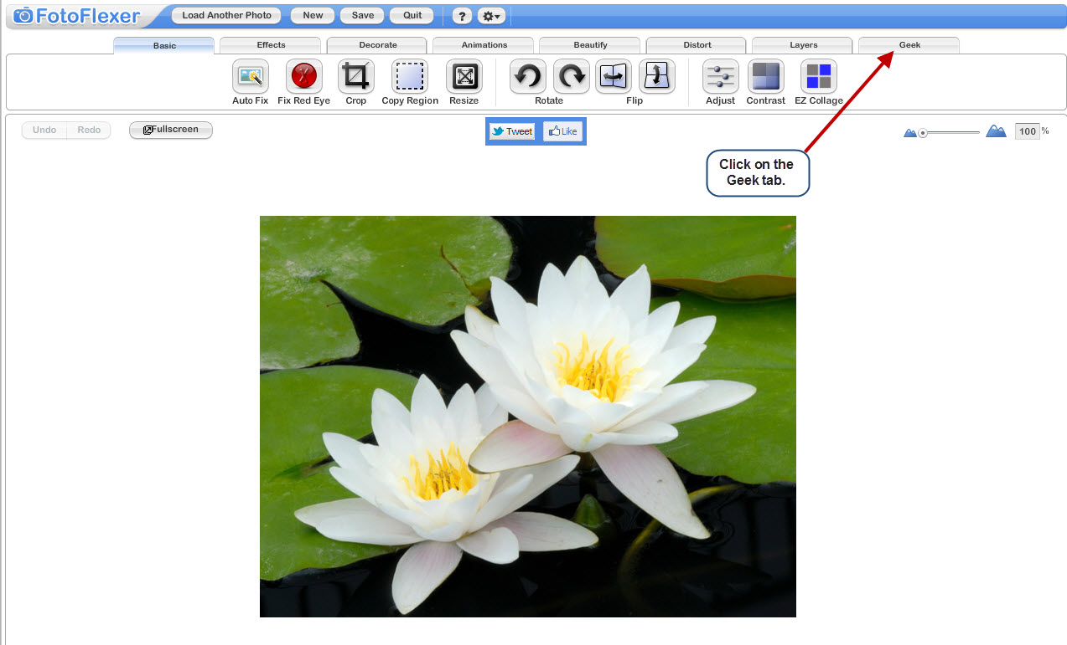
3. Click on the button for Full Screen. (You’ll need to stay in full screen mode.)  
     
   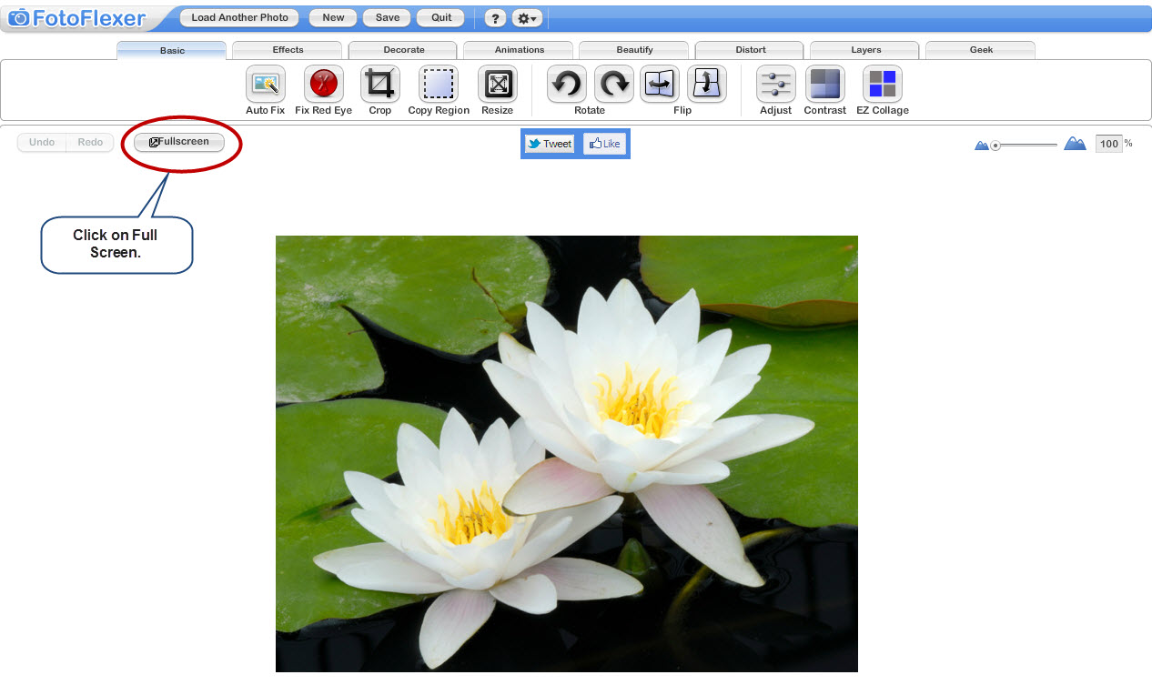
4. Click on the button for Smart Recolor.  
     
   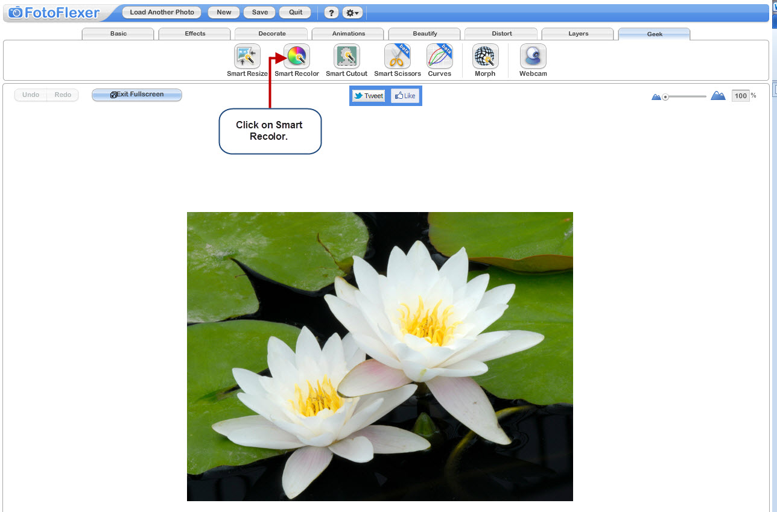
5. Change the brush size to Big.   
     
   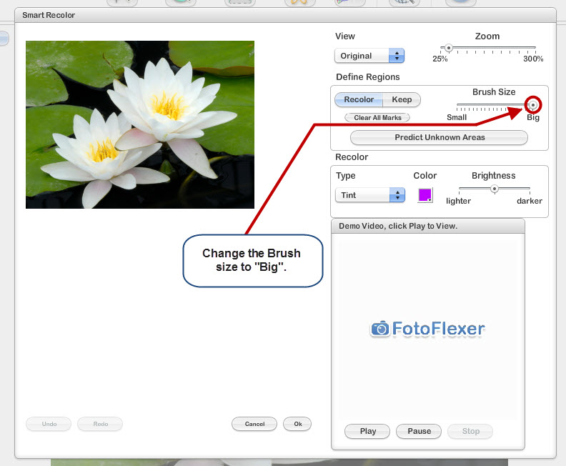
6. Your cursor will show up as a black solid circle (“paintbrush”) when you drag it across the image.   
     
   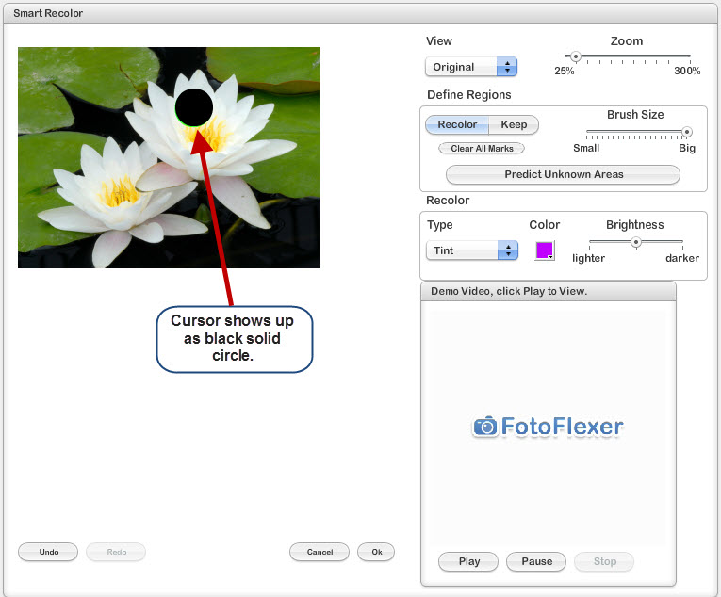
7. Dragging the paintbrush across will color green over the image. This is the area that will be changed to the new color. Cover “ALL” the image. It will all be green.  
     
   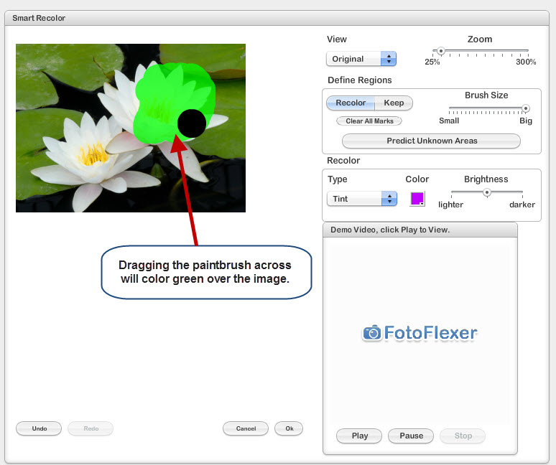
8. You can change the “View” from “Original” to “Processed” to make sure you covered it all.  
     
   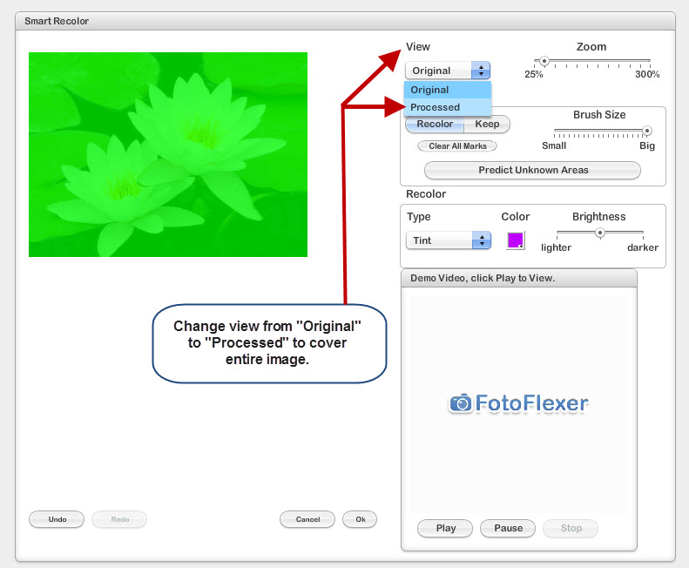
9. Change the “Type” from Tint to “Solid Color”  
     
   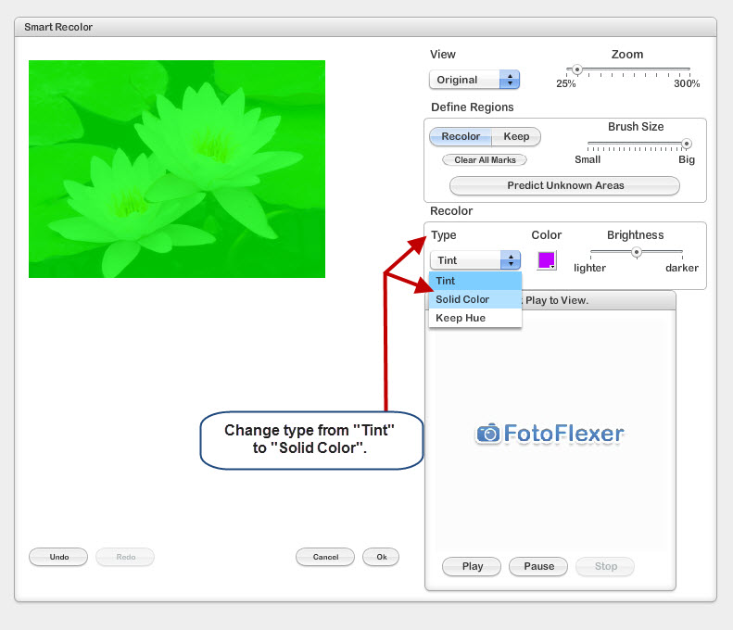
10. Click on the box beneath the word “Color” and choose the color you want for your blank slide.  
      
    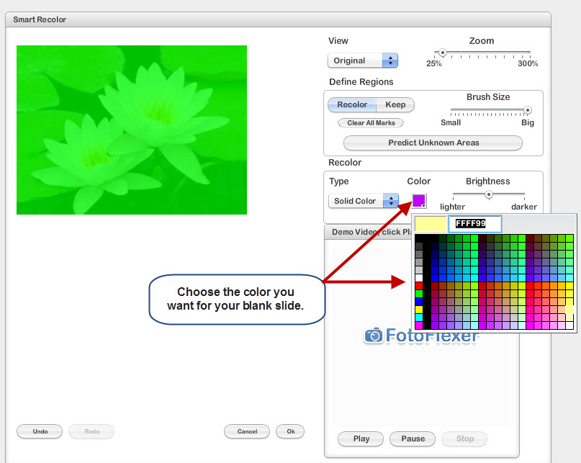
11. In the lower right hand corner, click “Ok”.  
      
    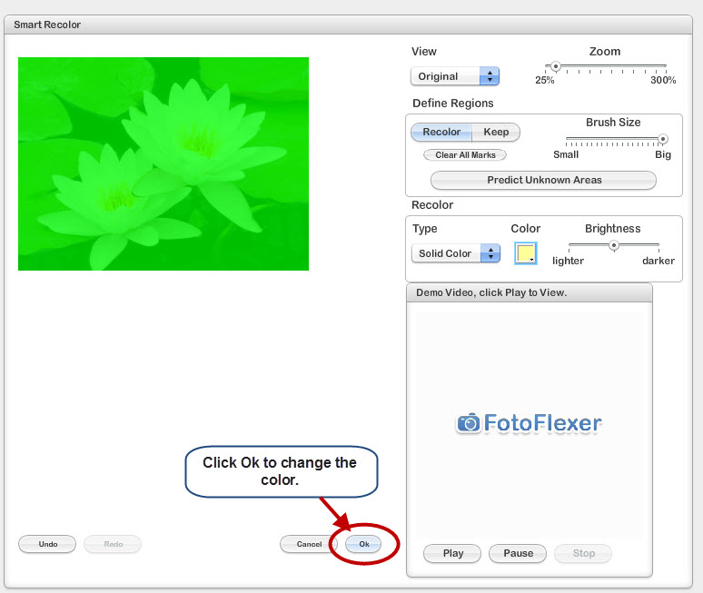

1. Save the image to your computer by clicking “save” on the menu bar at the top of the screen. You will want to save the file in either JPG or PNG format.  
      
   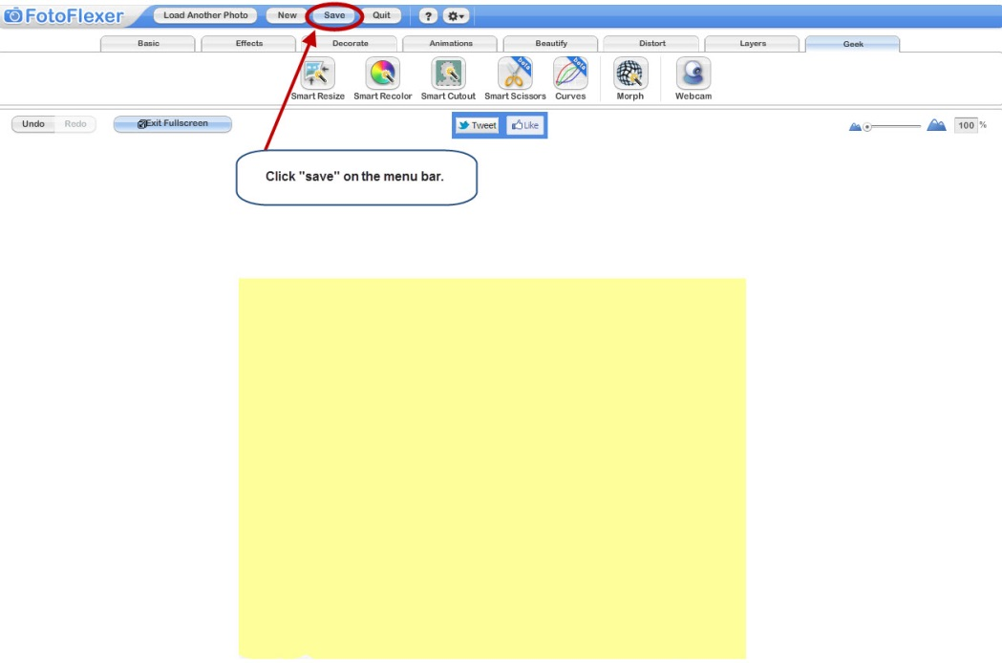
2. Click the “Save to My Computer” button.  
     
   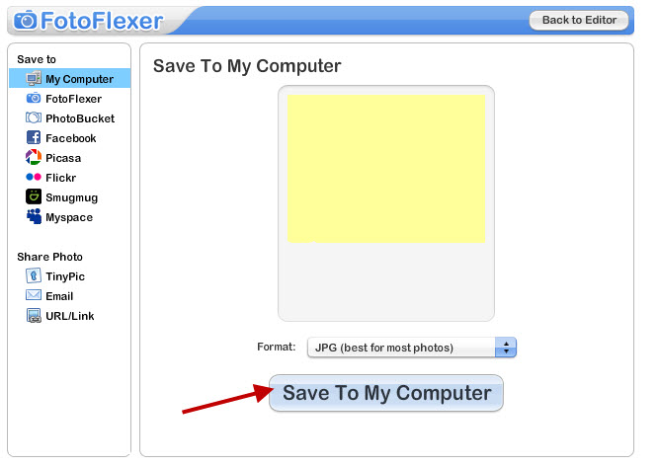
3. A “Save As” box will appear with a generic title “FotoFlexer_Photo.” Click the “Save Now” button.   
     
   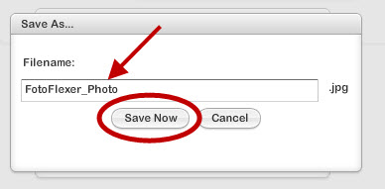
4. This will open the “Save As” box. Make sure that the Save In selection is in a location that you will be able to find when finished such as your Desktop or a folder you have created. Change the name of the file and give it a short meaningful name with no spaces (like “yellow_blank” and click “Save.”

