**Instructions for “Digital Self”   
Cropping, sizing, and Saving an Uploaded Image**

1. Obtain a digital photo of yourself, and save it to your computer. For the purpose of the tutorial a photo of a flower will be used.
2. Open <http://fotoflexer.com> and click the “Upload” button.  
     
   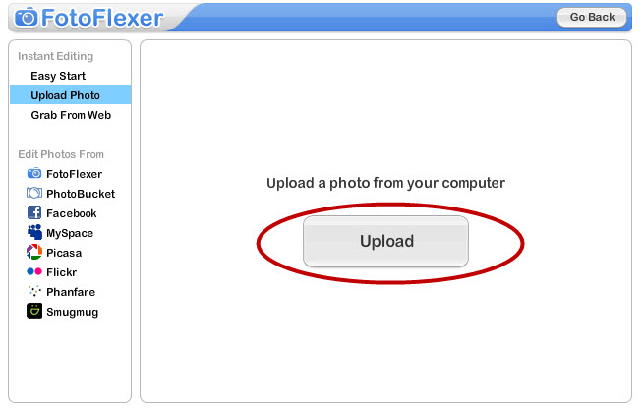
3. Browse to select the image, and click “Open”.  
     
   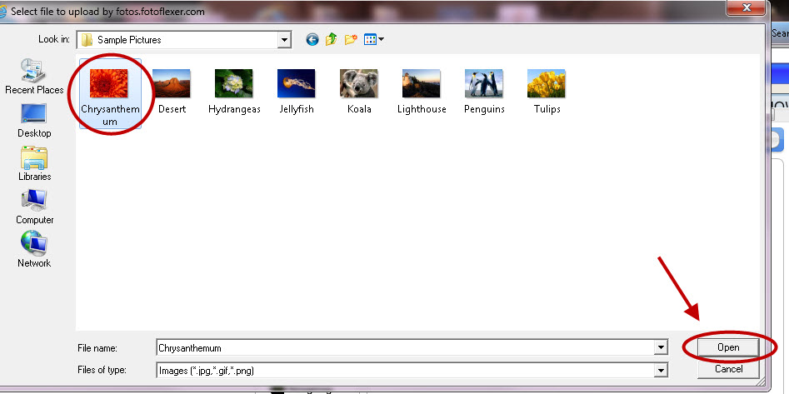
4. **To crop the image:** Once your photo has loaded, select the “Crop” button.  
     
   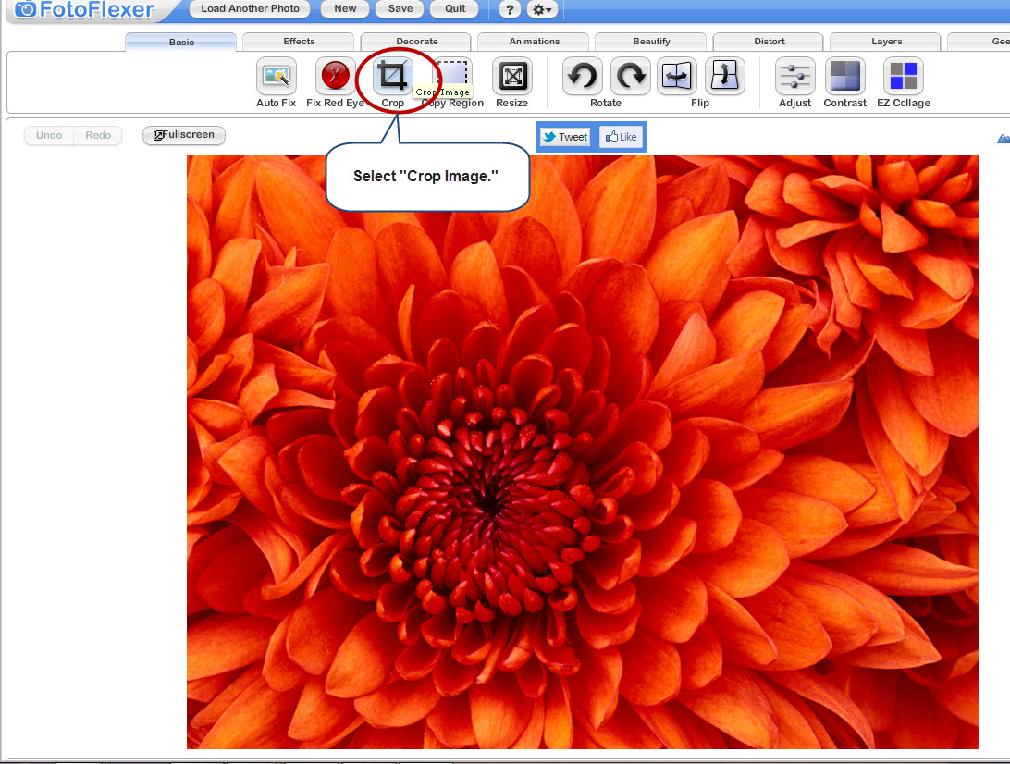
5. Click on the photo and drag to select the portion of your photo that you want to keep. You can adjust this selection by clicking and dragging the small blue boxes on the sides and corners.  
     
   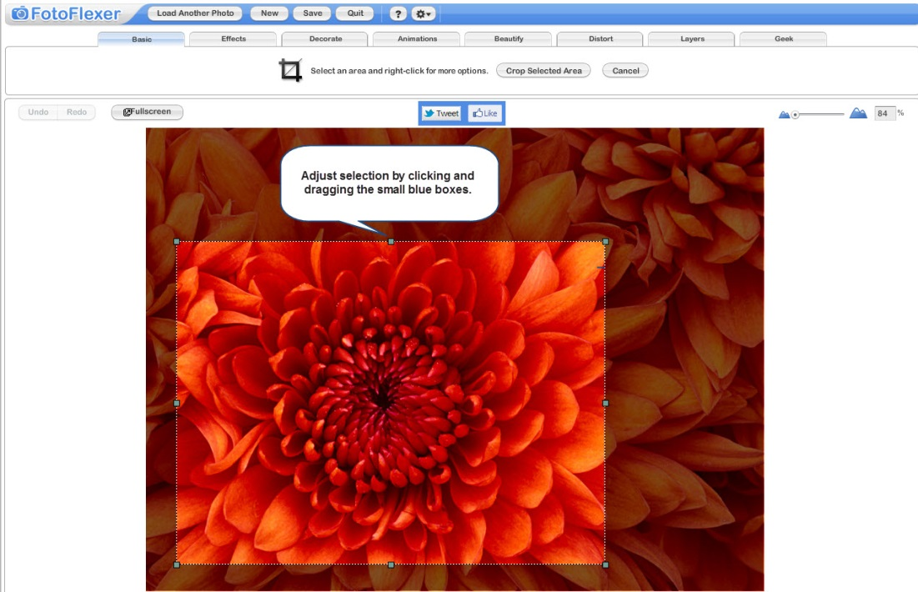
6. Click the blue button labeled “Crop Selected Area”. This will eliminate all the areas that were outside of your selection rectangle.  
     
   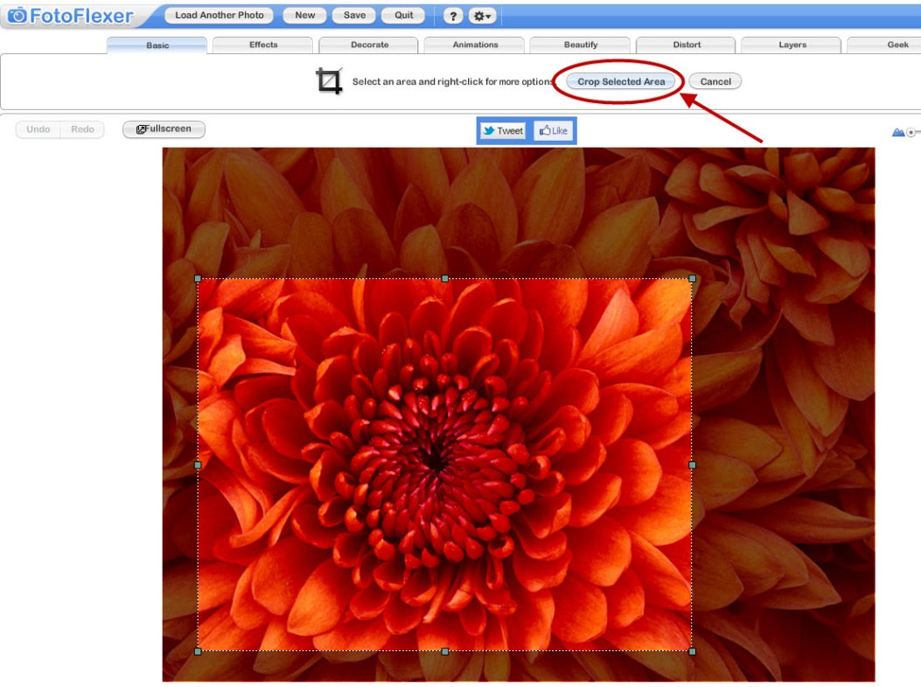
7. To resize the image: Click the “Resize” button.  
     
   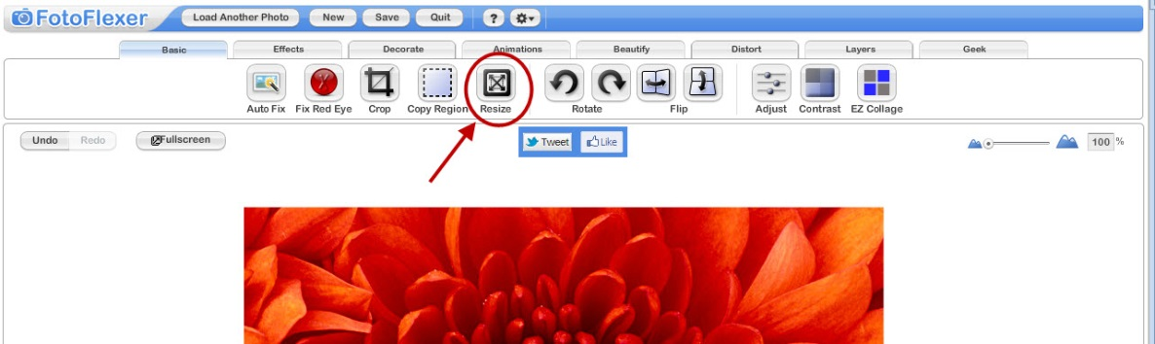
8. Next to the words “New Size:” are two windows with numbers that represent the image size in pixels. The second window sets the height.   
     
   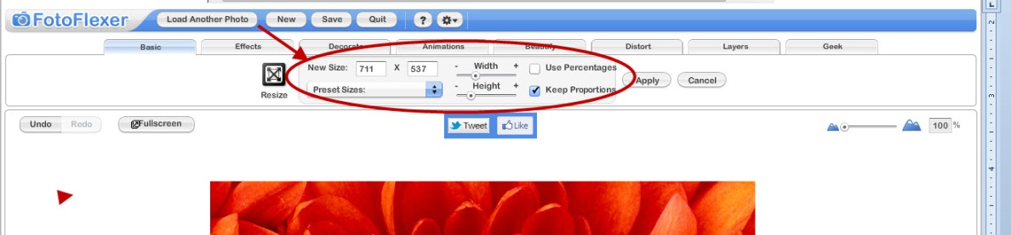
9. Type 150 into the second window. The value in the first window will adjust automatically.  
     
   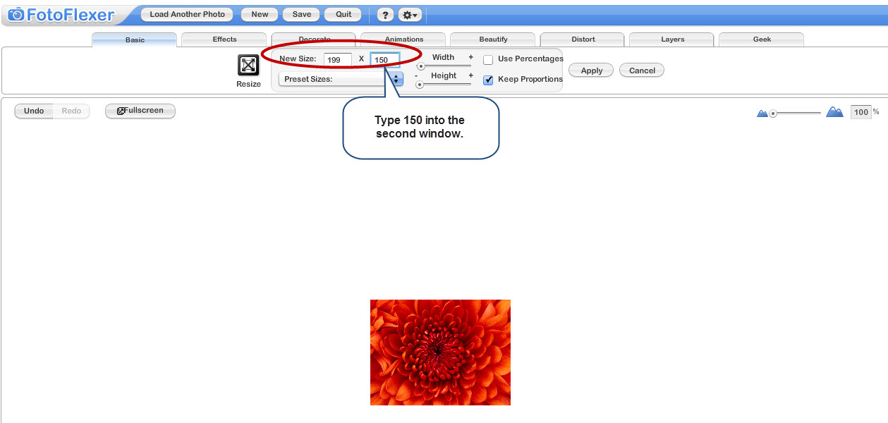
10. Click “Apply”.  
      
    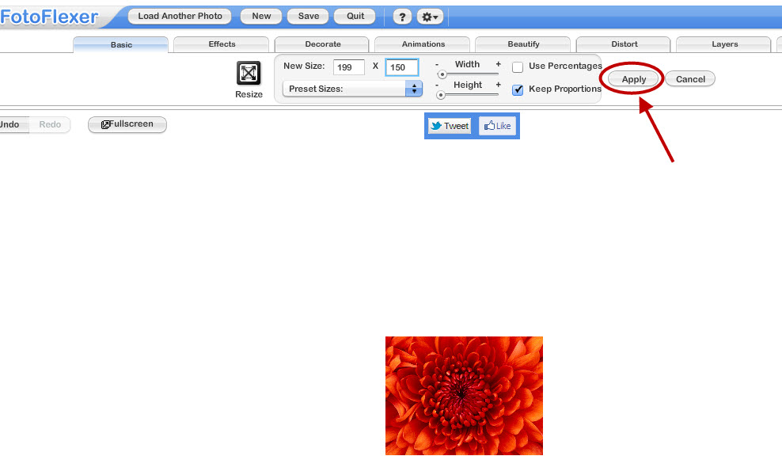

1. Locate the “Save” button in the blue horizontal band and click it.   
     
   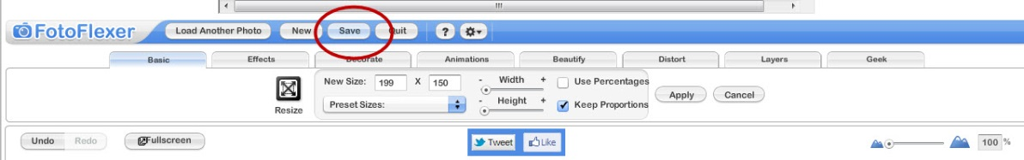
2. It will automatically suggest the image format “JPG” which is best for most photos. Click the button “Save To My Computer.”  
     
   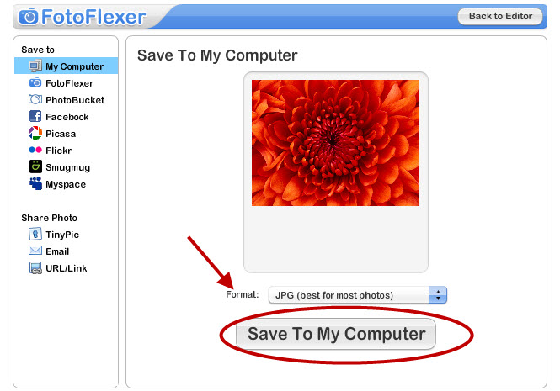
3. Give it a short, meaningful name (with NO spaces), and click “Save Now.”  
     
   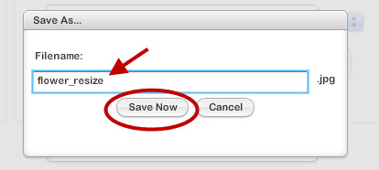
4. Browse to select the location to download the newly cropped and sized image, and click “Save.”

