Changing and Managing the UHCL ePortfolio Template

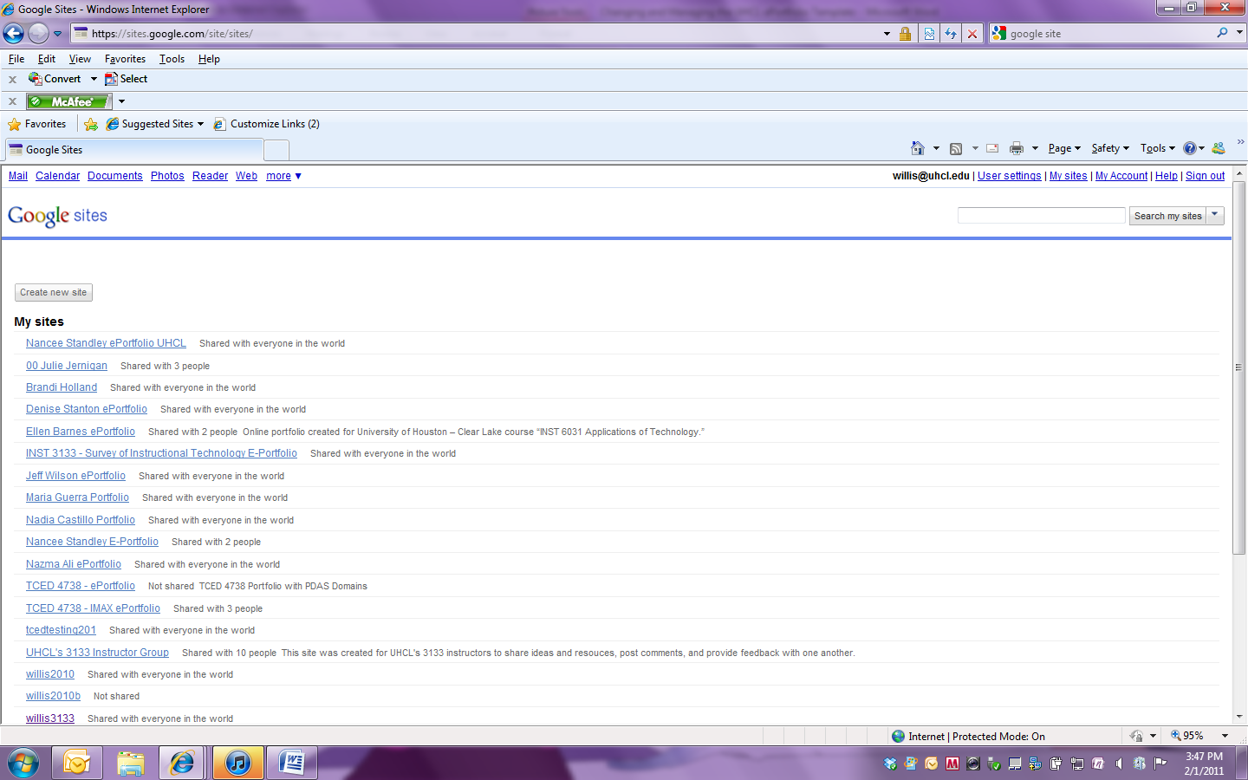

Click on the UHCL ePortfolio that you created.

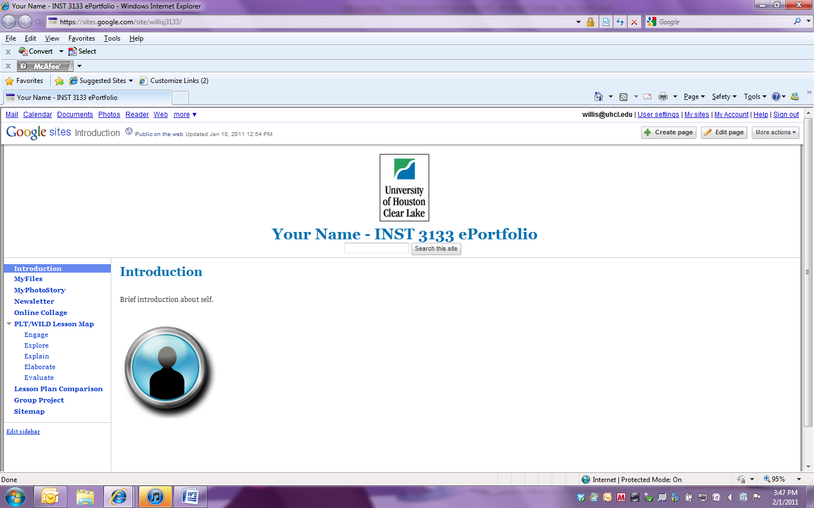

To modify the heading on your ePortfolio click on More Actions.

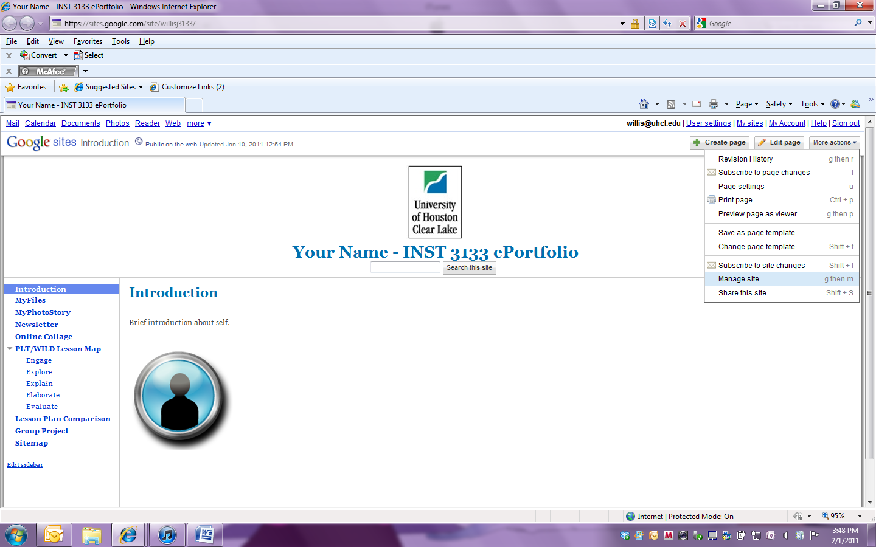

Select Manage site.

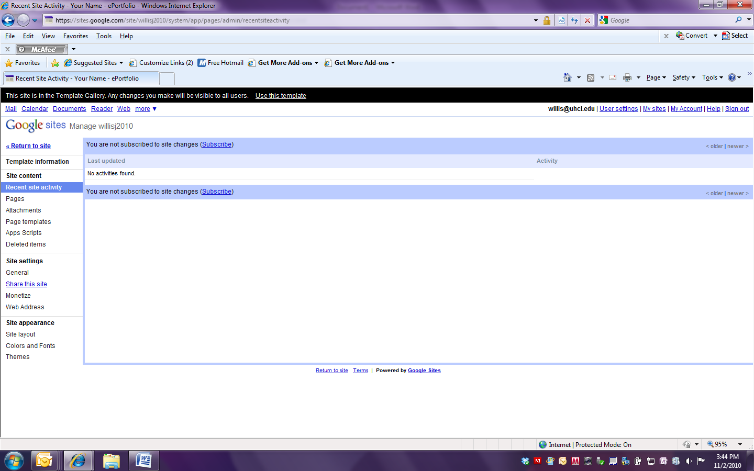

Click on General.

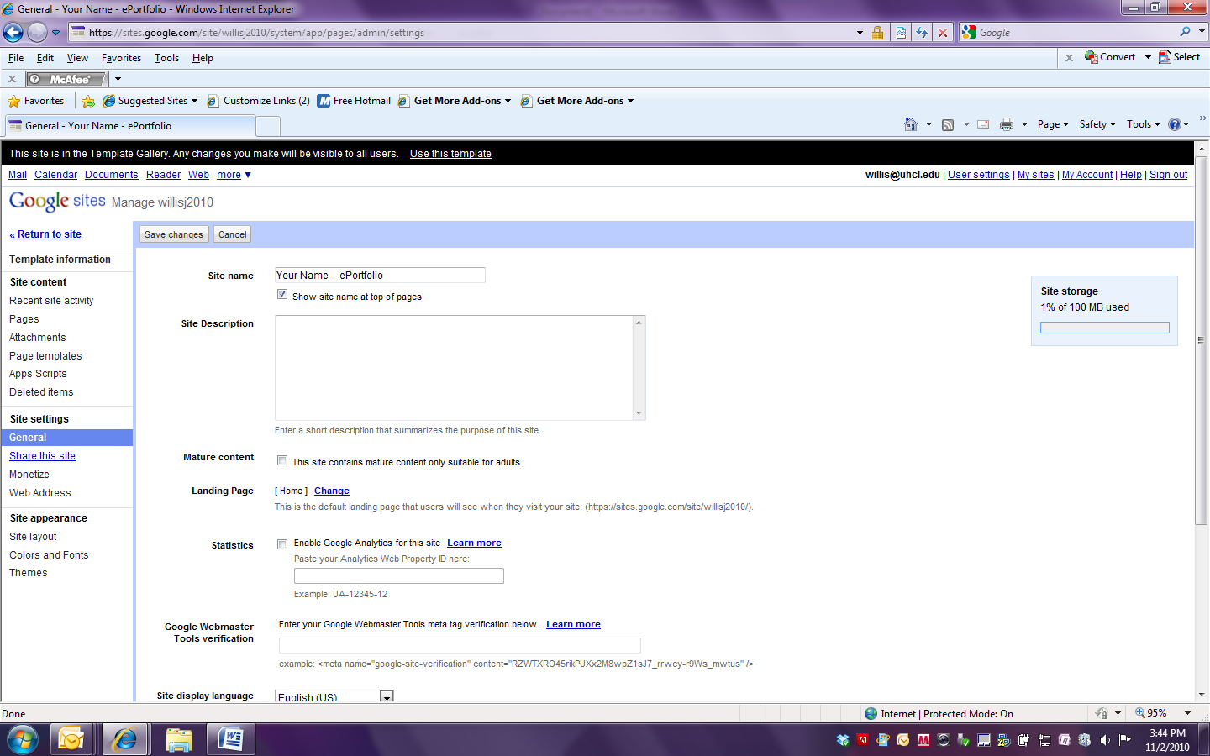

Modify the site name to be your name. Then Click on Save changes.

Click on Return to site to return to the main screen.