Google Sites

Access the Google sites website at <http://sites.google.com>

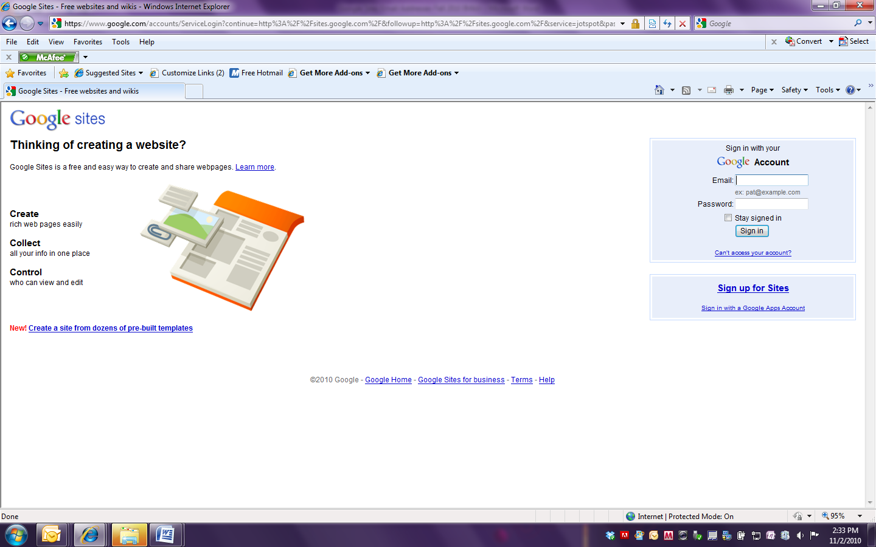

If you have a Google account you can login to and get started.

If you do not already have a Google account, you can easily create one. Click here to begin creating your Google login.

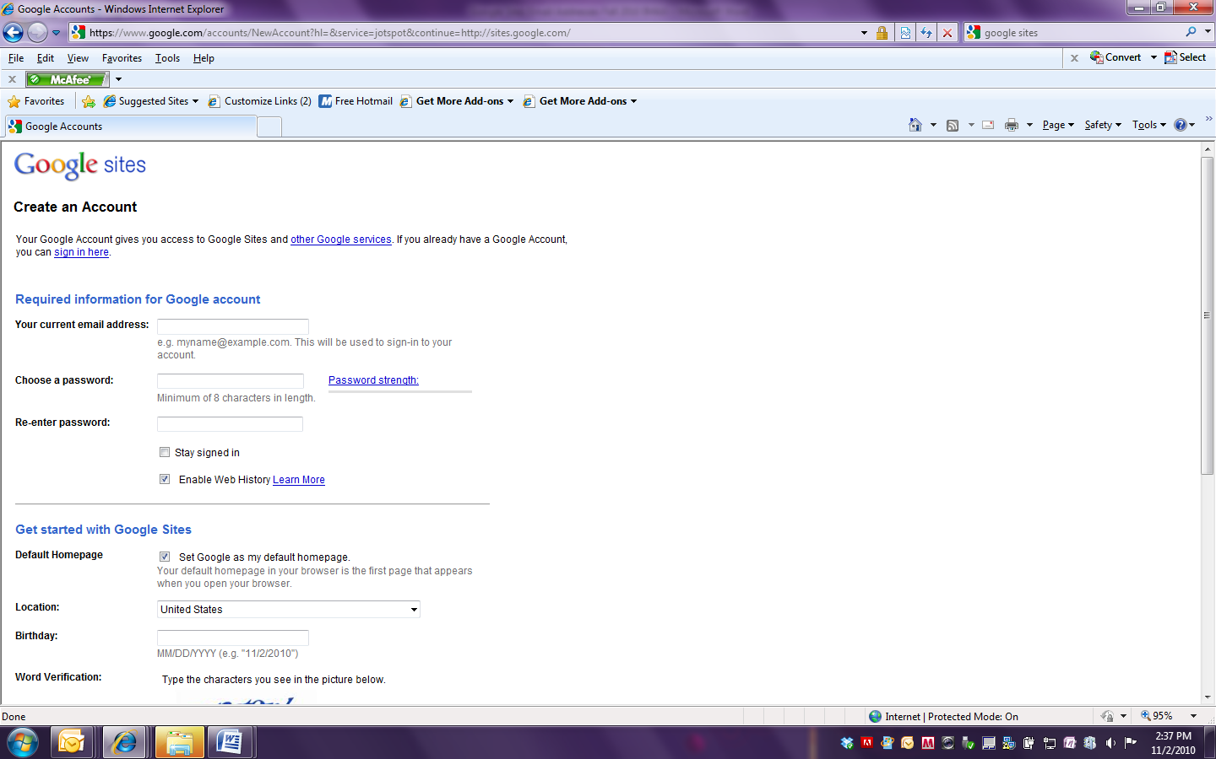

To prevent the resetting of your Internet Explorer home page be sure and remove the following option:

|  |  |
| --- | --- |
| **Default Homepage** | Set Google as my default homepage.  Your default homepage in your browser is the first page that appears when you open your browser. |

Once you have a Google Account you are ready to login and get started. If you have used Google Sites before you will find a list of your existing sites on your Sites page. To begin your work on our ePortfolio we will be creating a new site based on an existing template. So click on Create new site.

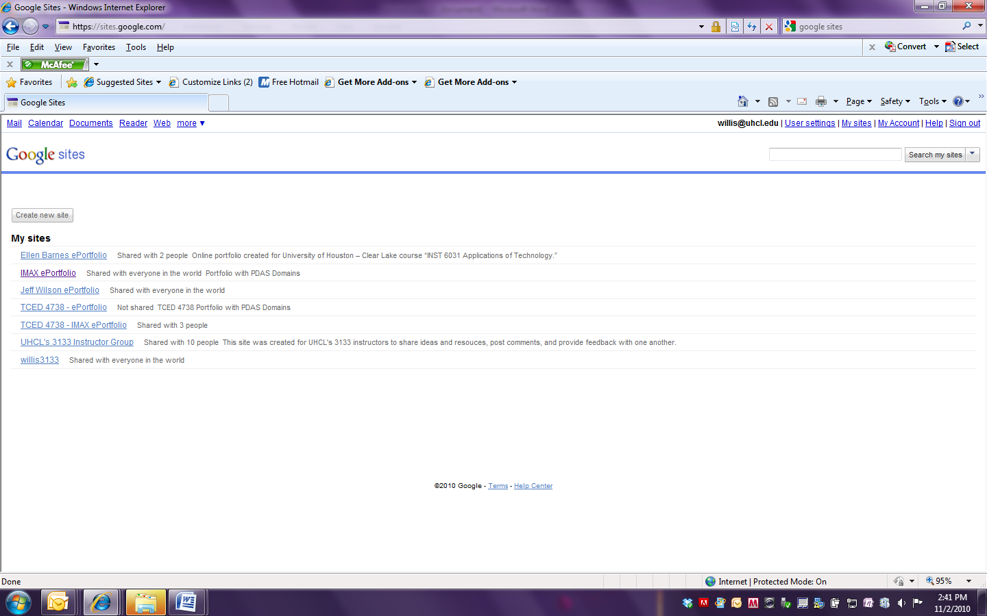

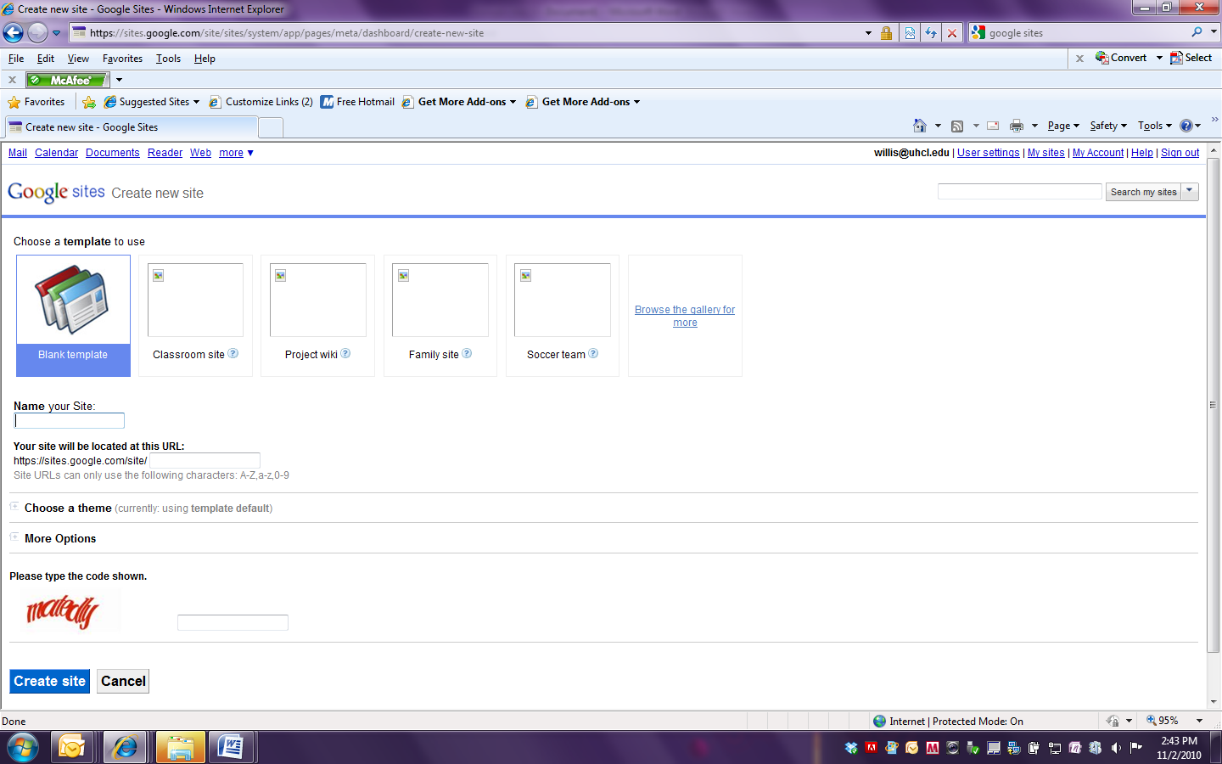

Select Browse the gallery for more.

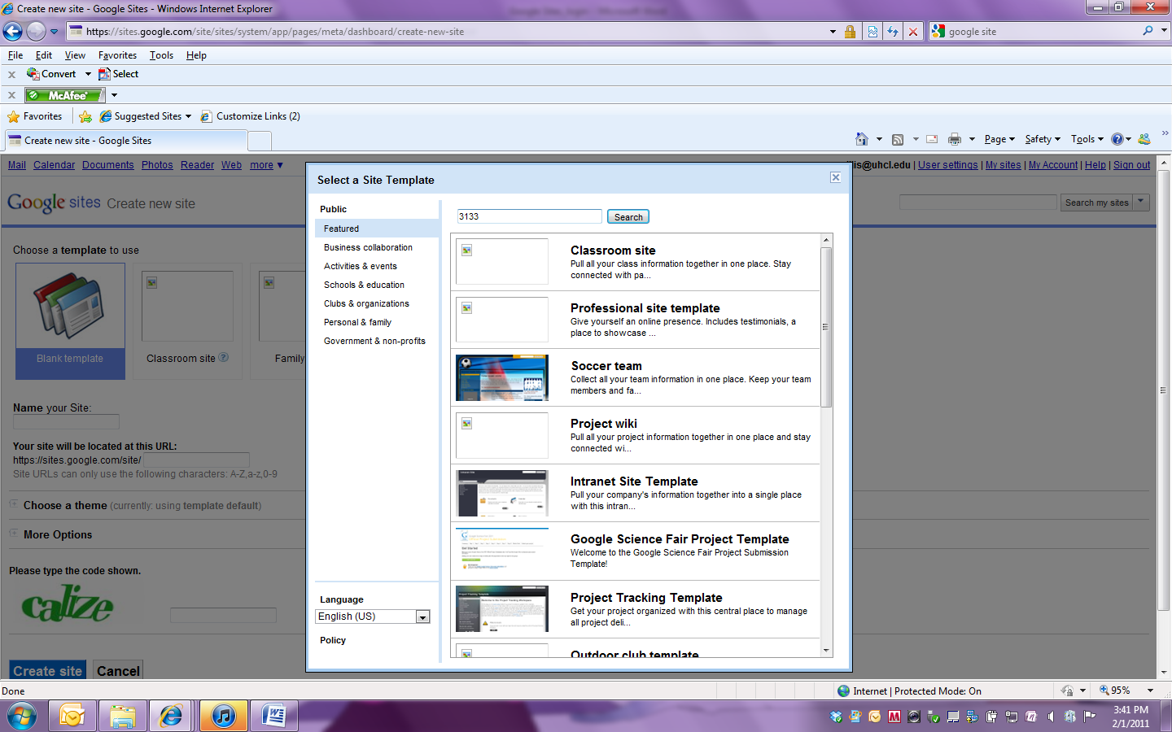

Enter 3133 in the Search field and click on Search.

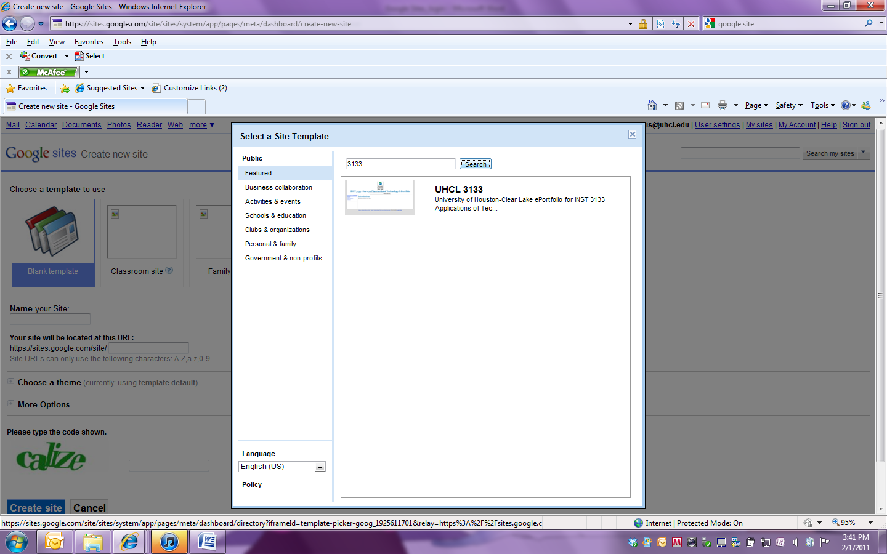

Click on the UHCL 3133 ePortfolio template.

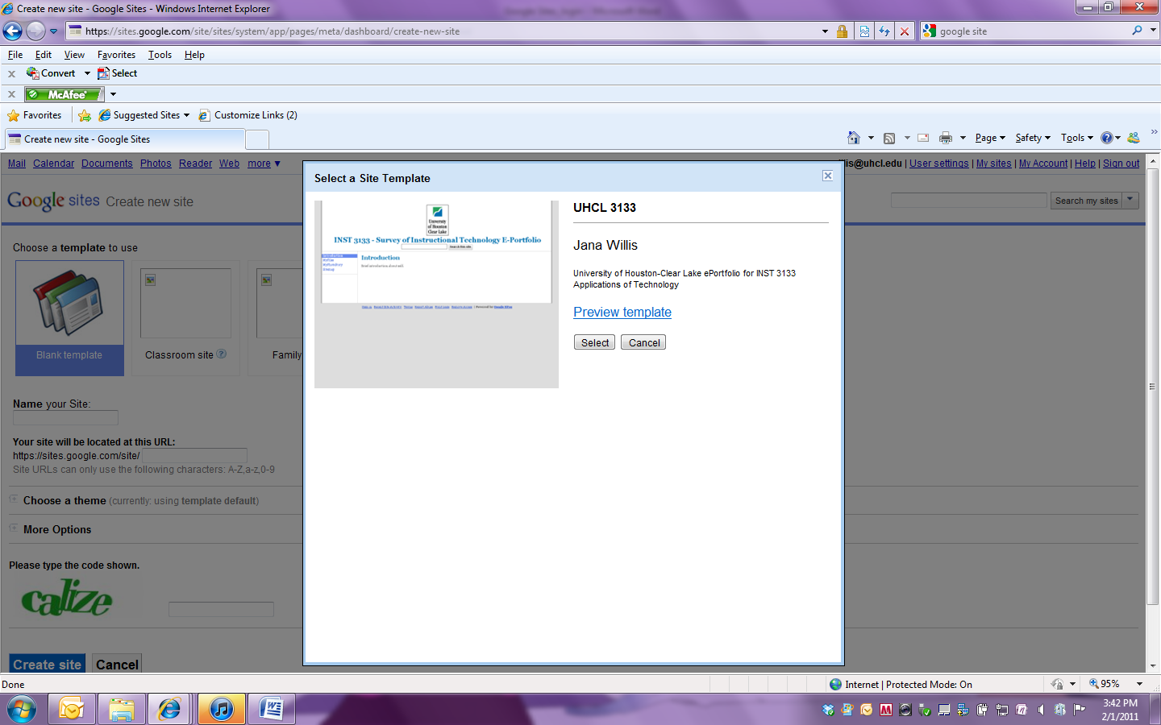

Click on Select.

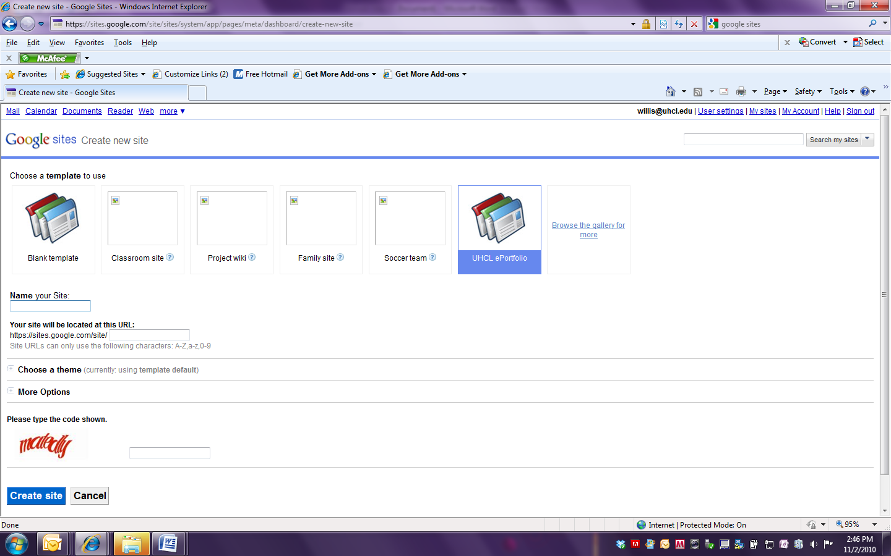

Name your ePortfolio site. Make note of the URL for your site.

Click on Create site. The system will occasionally hang here but do not worry the site is still created. You may have to logout and log back in to see your new site.

Once your site has been created you can begin to make it your own.