Inserting an Image on Google Sites

Login to your Google Site

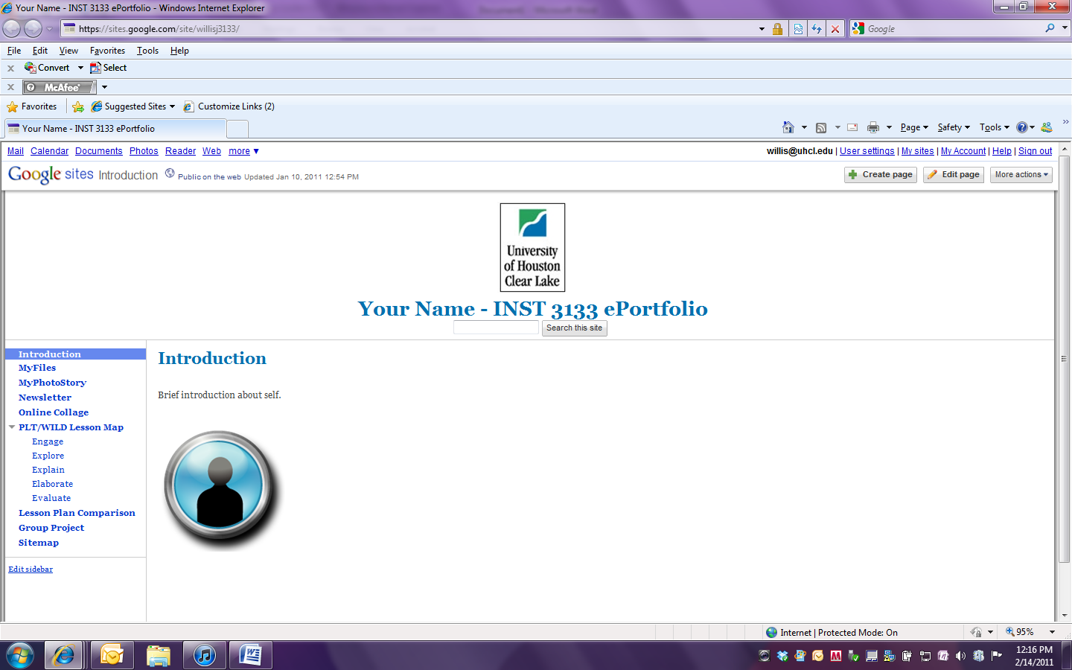

Click on Edit Page. A new window will appear with the page in edit mode.



Click on the image placeholder.

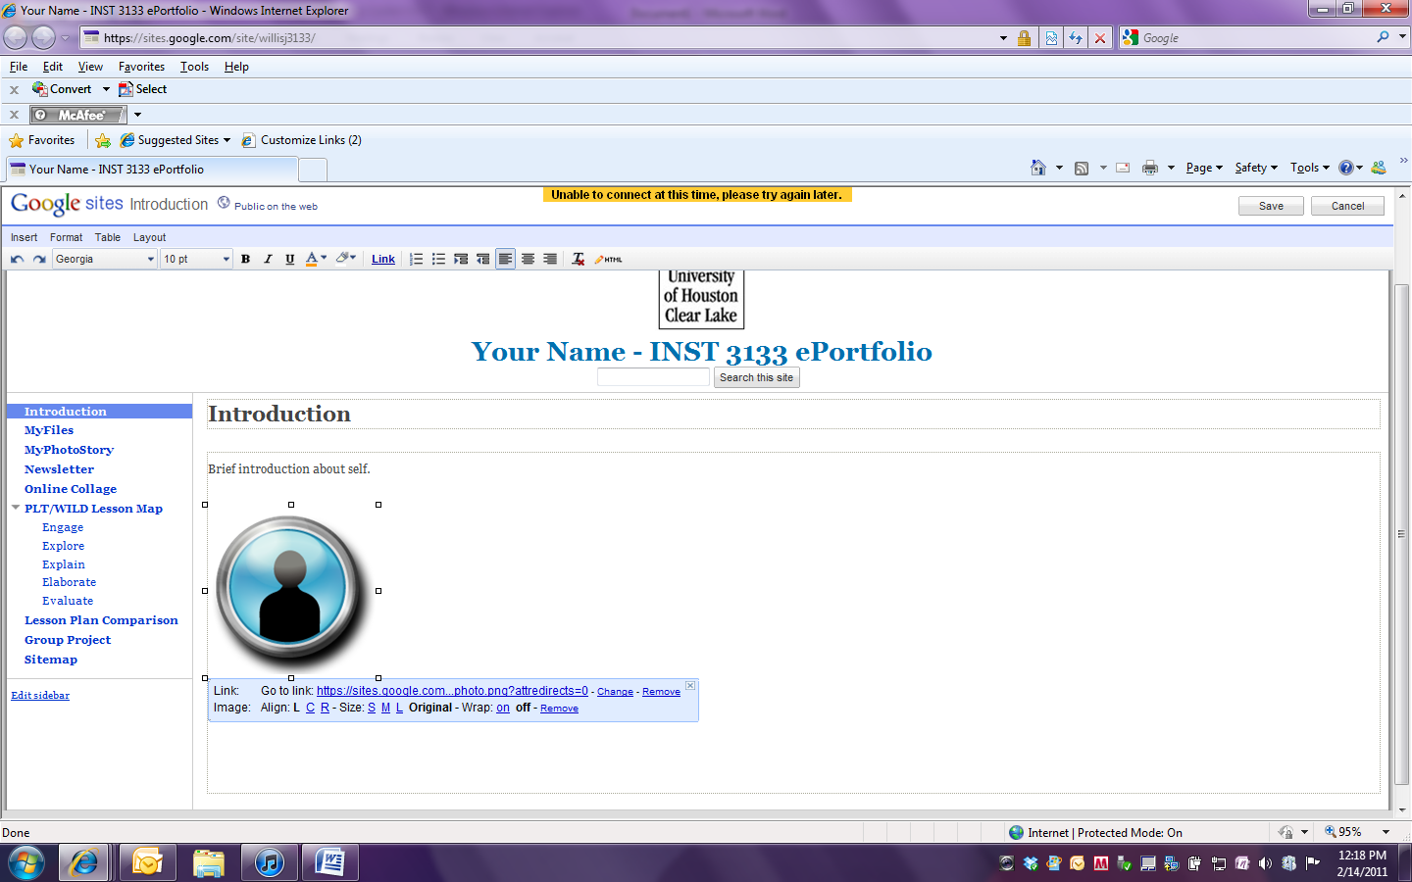

An edit box will appear under the placeholder. Click on the Remove option in the Image line to delete the placeholder. The placeholder will be deleted.

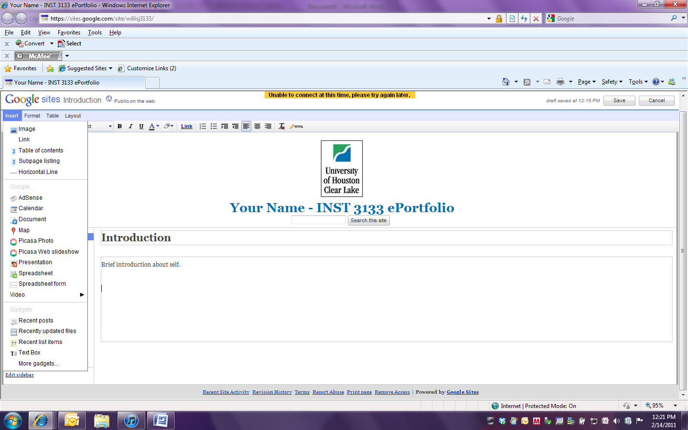

To insert a new image, click on Insert and from the drop down menu choose Image.

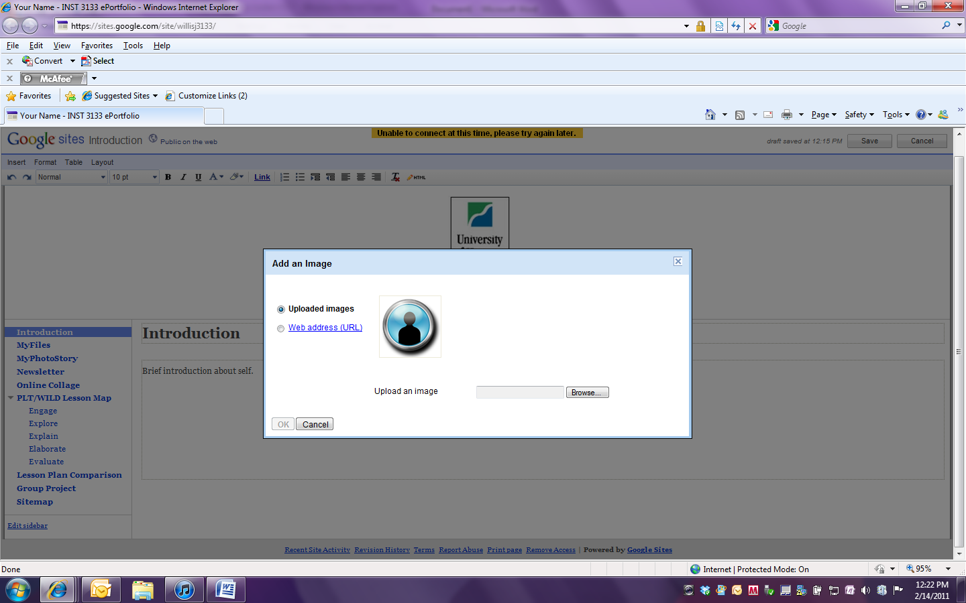

You will get a pop-up window with a Browse option to allow you to browse your computer for the image to be inserted.

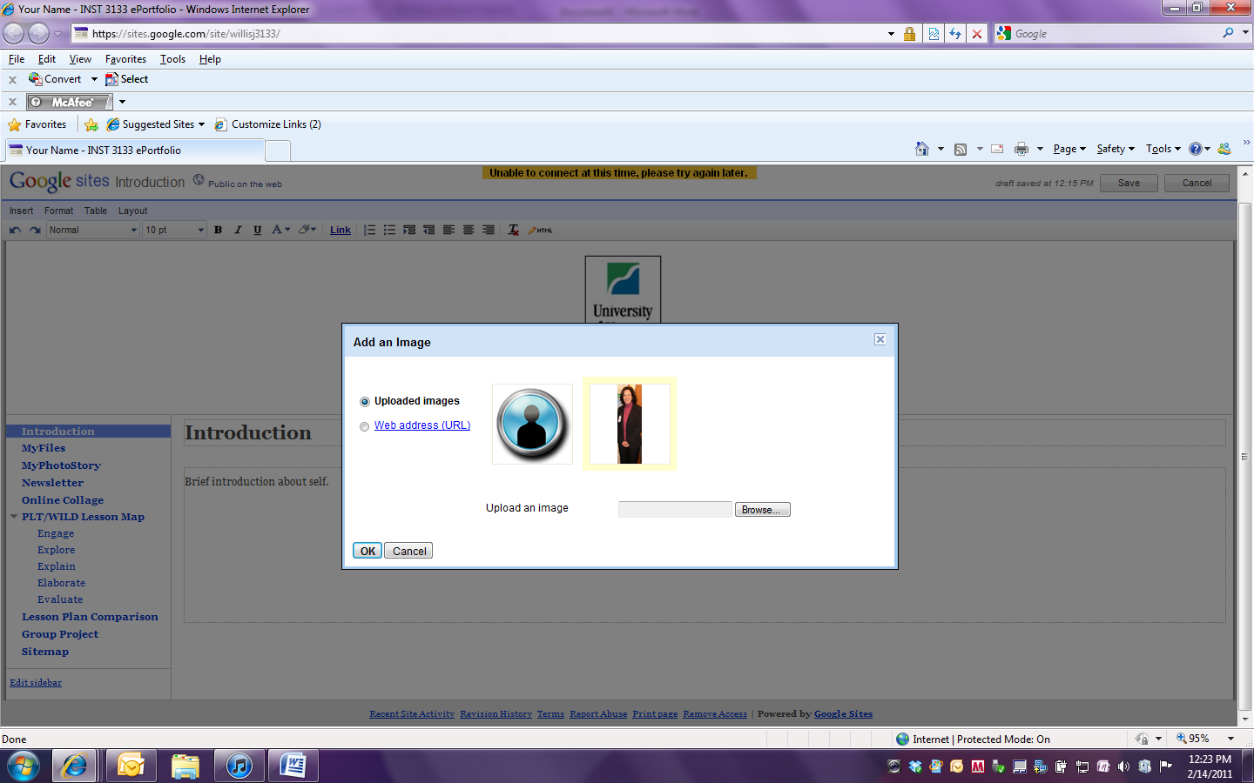

Once you have selected the image click on OK.

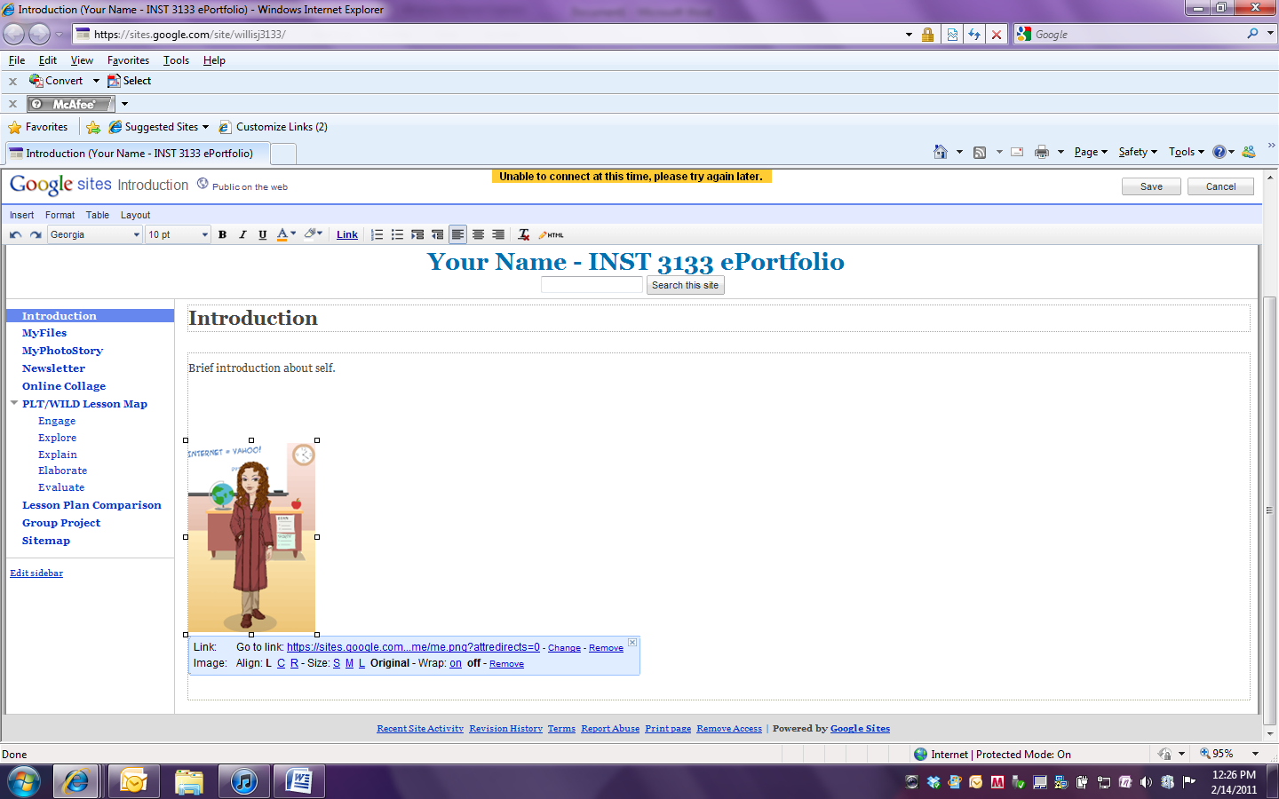

Once the image is uploaded you can adjust the size and placement of the image. Once you have made all adjustments you should click on Save.