Converting an Inspiration file (filename.isf) into an image file (filename.png)

*Important notes: You canNOT just re-name the file and type the change.
Files can only be converted from one format to another by using an appropriate computer program.
Do not delete the original .isf file – you need it in case you want/need to make a change to the file.

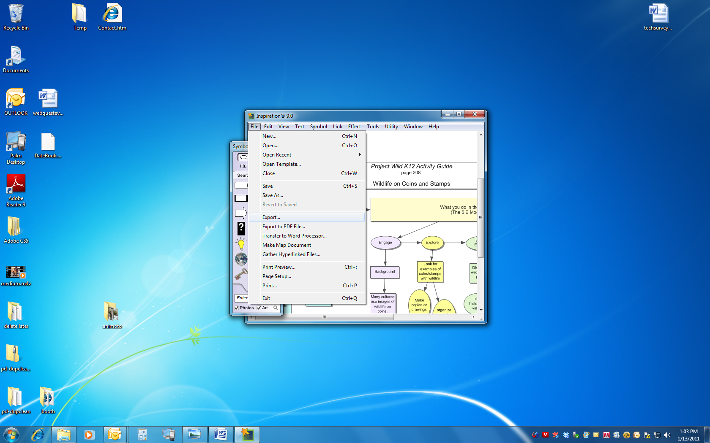
- You must already have the Inspiration software installed on the computer you are using, or an Inspiration file will not open on that computer.
- Open the file in Inspiration, and click on the File button.
- On the pull-down menu, choose “Export”
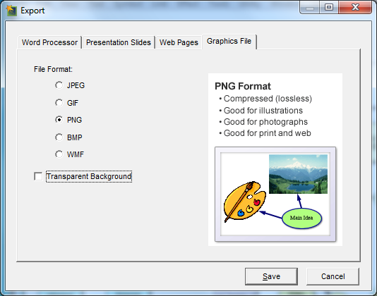
- The Export dialog box appears.
- Choose the “Graphics File” tab.
- Click the radio button to select “PNG”.
(This is a good format to use on Web pages.)
- UN-check the box next to “Transparent Background”
(This will give the graphic a white background.)
- Click the “Save” button
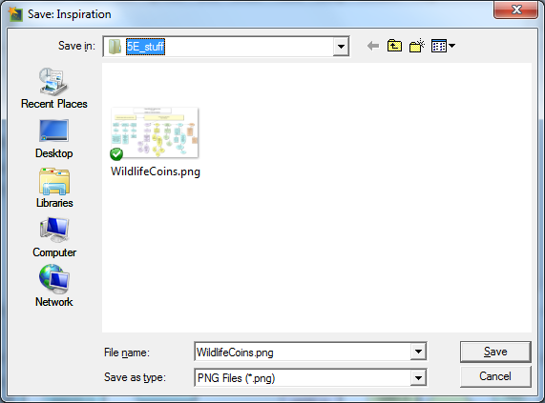
- On the next popup box, make sure you are saving it to the folder of your choice.
Don’t let the computer decide for you.
It will automatically try to give it the same name as the .isf file. (OK if you named the original file with a short, meaningful name and NO spaces in it.)
The save process will put the .png on the end for you.
- Click the “Save” button on this screen to finish.

