Teacher as Self – Inspiration Diagram Assignment

Important Note: This is a tutorial for the SKILL SETS required in the assignment.
It is not intended to be a step-by-step for the exact assignment, because specific assignment criteria may change from semester to semester.
You are responsible for reading the assignment criteria as posted in the course webpage.

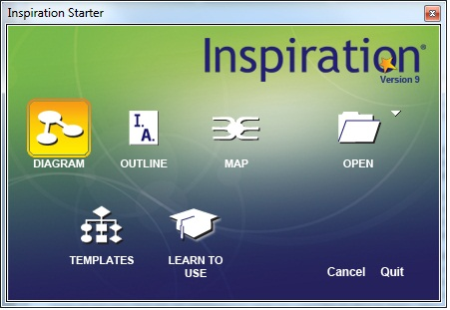
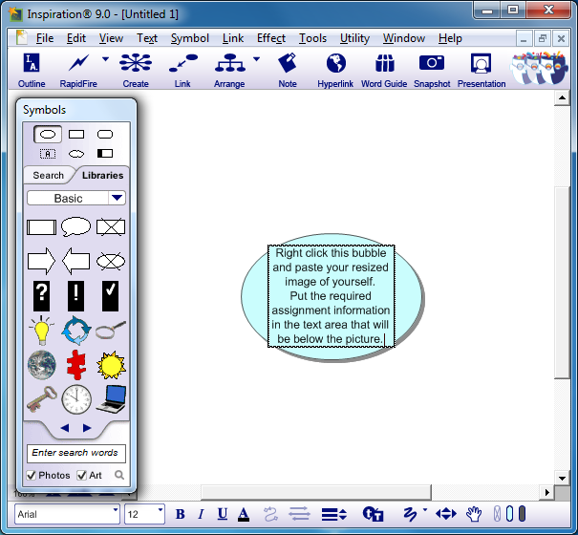
- Open the Inspiration program and choose the button labeled "Diagram".
- Copy the resized digital image of yourself and paste in the center (main idea) bubble of your Inspiration map.
- Replace the "main idea" text with your full name, course section number (ex. Jane Smith - INST 3133.03).
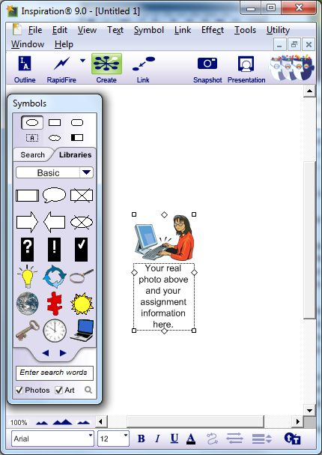 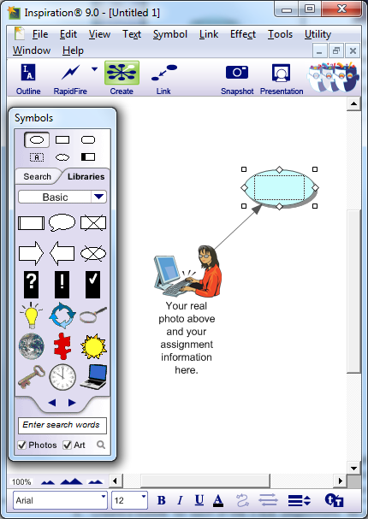
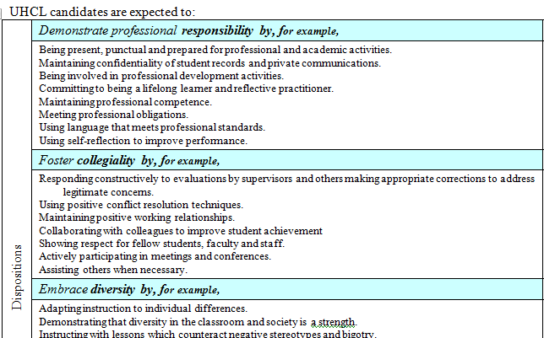
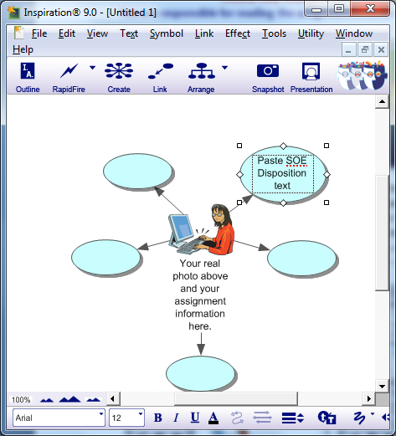
- Click the original “bubble” to select it. Locate the “Create” button at the top. It looks like an octopus shape. When you move your cursor across it, a different arm of the button will turn white. Click the arm in the direction you would like your next bubble to appear.
Once you create a bubble you can click on it and move it around.
The arrow will stay connected.
- Create a bubble for each of the 5 SOE Dispositions. Be sure there are links between your image and the disposition bubbles.
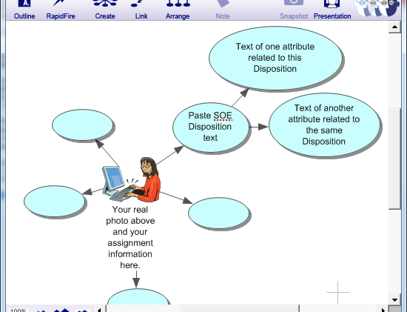
- Copy and paste the Disposition text (the part in blue on the SOE Disposition form) into the individual bubbles.
- Create two new bubbles linked from each of the 5 dispositions bubbles.
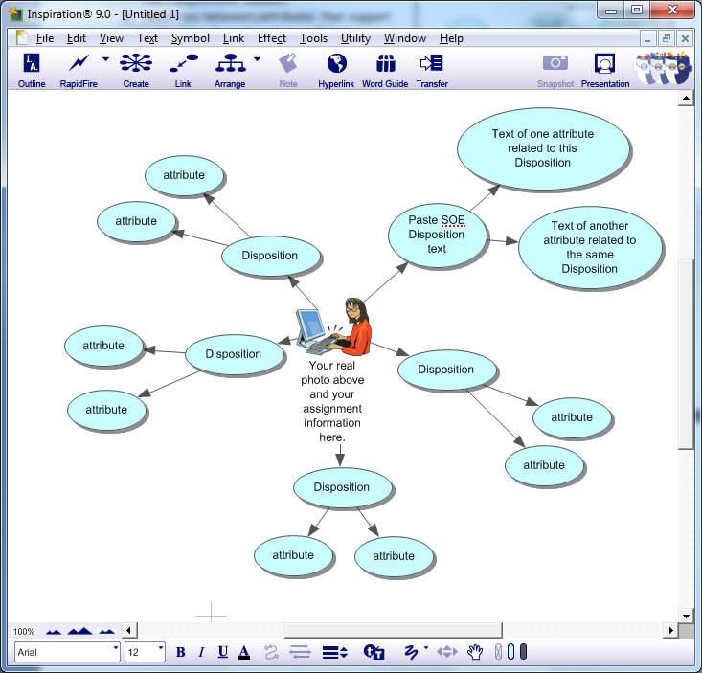
- Select two behaviors/attributes that support each of the dispositions (you will find examples listed in the white area on the disposition form beneath each disposition.) but you are not limited to the items listed)
- Enter the two behaviors/attributes(text) identified for each of the five dispositions into the newly created bubbles.
The elements listed in the course assignment are required, but your page does not have to look exactly like this example.

- Replace the ten behavior/attribute bubbles with graphics from the Inspiration libraries to provide a conceptual representation of your stated attributes/behaviors. Choose a different picture for each one, because they each have a different idea in them.
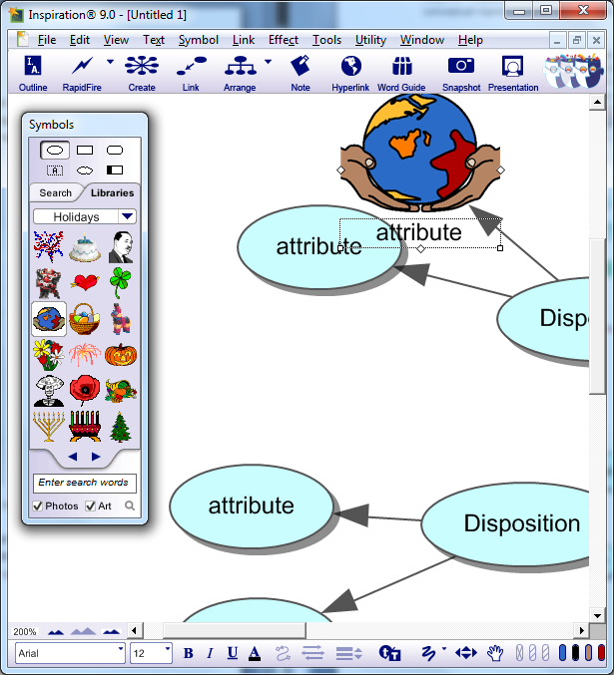
- Use the green arrow on the Libraries Tab to explore all the clip art that you can use inside of Inspiration. When you find an image you like, click on it. It will replace the bubble, and the text will be moved beneath the image. You will need to rearrange the images for best fits.
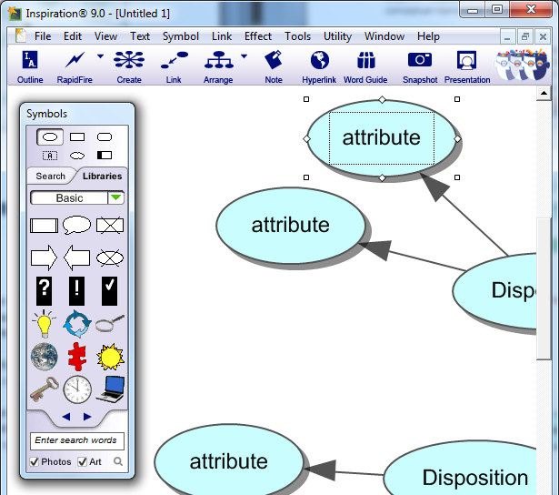
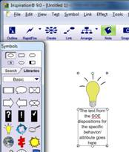
After you have made the 10 bubbles into 10 graphics:
- Click on a graphic to select it, and locate the “Notes” button on the top menu. Once you click on the notes button, a yellow text area will slide out. Click inside the yellow area to type.
- For each of the behaviors/attributes use the notes feature to explain in full sentences why as a future teacher you value the selected behaviors/attributes.
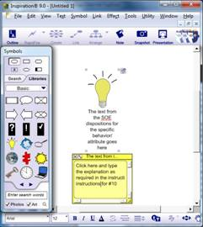
- Drag the yellow boxes around so they do not cover up anything. You can leave all the yellow boxes open.
- Save the completed Inspiration file to your computer or to an external storage device. (Give it a short, meaningful name with NO spaces. Make sure that you know into which folder you are saving it - don't let the computer choose this for you.) This file will have an .isf ending (extension).
- Refer to the assignment grading rubric before submitting.

