Working with InspireData

**Important Note: The following steps illustrate the SKILL SETS required in an assignment. These steps are NOT intended as tutorial for the assignment instructions. Assignment instructions may vary from semester to semester. You are responsible for reading and following the current assignment instructions as stated in the current course Webpage.

When you ask students to work with information in a database, look for ways to ask them to compare the data instead of just reading a single fact from a cell.

Look at the following InspireData database (“Are You a Square?”)

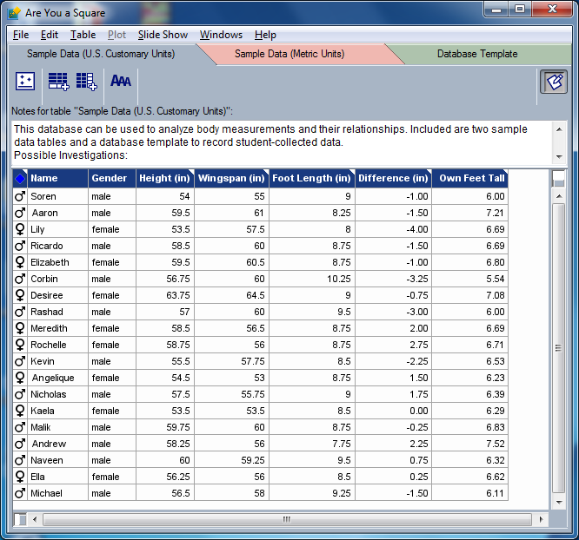

Some of the InspireData databases are very complex. In this database, I am interested in using data for all the entries, their gender, their height and their wingspan. I am going to ignore the extra columns in my “lesson.”

The entries appear to be in no particular or logical order. Sometimes data is just entered in the order in which it is received. Your textbook covers much of the essential information on working with data. However, you can help clarify the information if you rearrange it. In databases, this process starts with “sorting.”

*Note: Always start by saving a copy of a database that you plan to change, so that if anything goes wrong, you can simply and easily retrieve a clean copy of the original file.
- I want to first group by gender so I can look at differences between those 2 groups.
- After that, I want the wingspan column arranged to show me the wingspans from shortest to longest within each group.
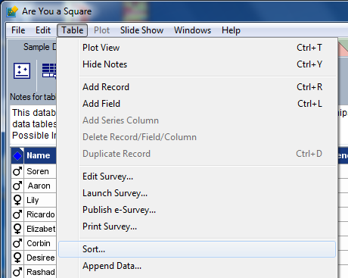
How to sort an InspireData database

- At the top, go to “Table” and pull down to “Sort.”
- A new dialog box appears. Under the heading “Sort table” click the down arrow to see the different fields by which you can sort.
- In this example I first chose Gender.

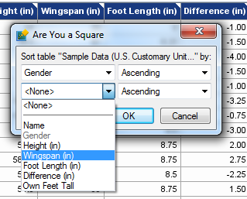
- Following that, I can select another field – I chose “Wingspan.”

- Click “OK.”
(See the next page for the sorted database.)

- Now the database information is grouped by females and males.
- Within each gender, the participants are rearranged by their wingspan, from shortest to longest.
Remember: When you ask students to work with information in a database, look for ways to ask them to compare the data instead of just reading a single fact from a cell.
An example of a higher order question for this database could be:
How many females had wingspans that were longer than their height?
- Unused columns can be deleted by right-clicking at the top of the unwanted column and selecting “Delete Field.”

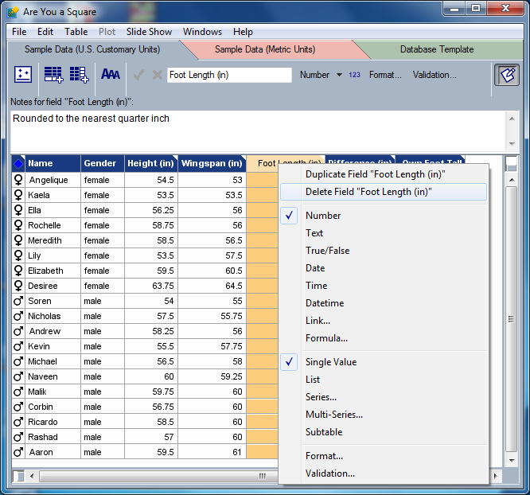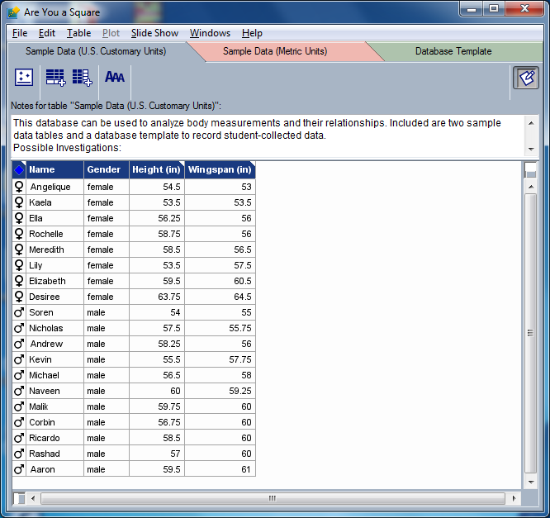

- You will need to take a screen capture of your sorted table. To do this, make sure that the InspireData window is active by clicking it anywhere in the bar (above the File/Edit/… menu) at the very top of the InspireData window.
- Hold down the Alt key on the keyboard. (This will cause the screen capture to only capture the active window, instead of everything you see on your computer monitor.)
- While holding the Alt key down, press the PrtScn (PrintScreen) key. This is usually located on the upper right side of the keyboard. This copies a “picture” of the active window.
- Paste this copied image of your sorted InspireData database into the template provided in the assignment.

