Downloading a Template from Microsoft

Connect to <http://office.microsoft.com/en-us/templates/>

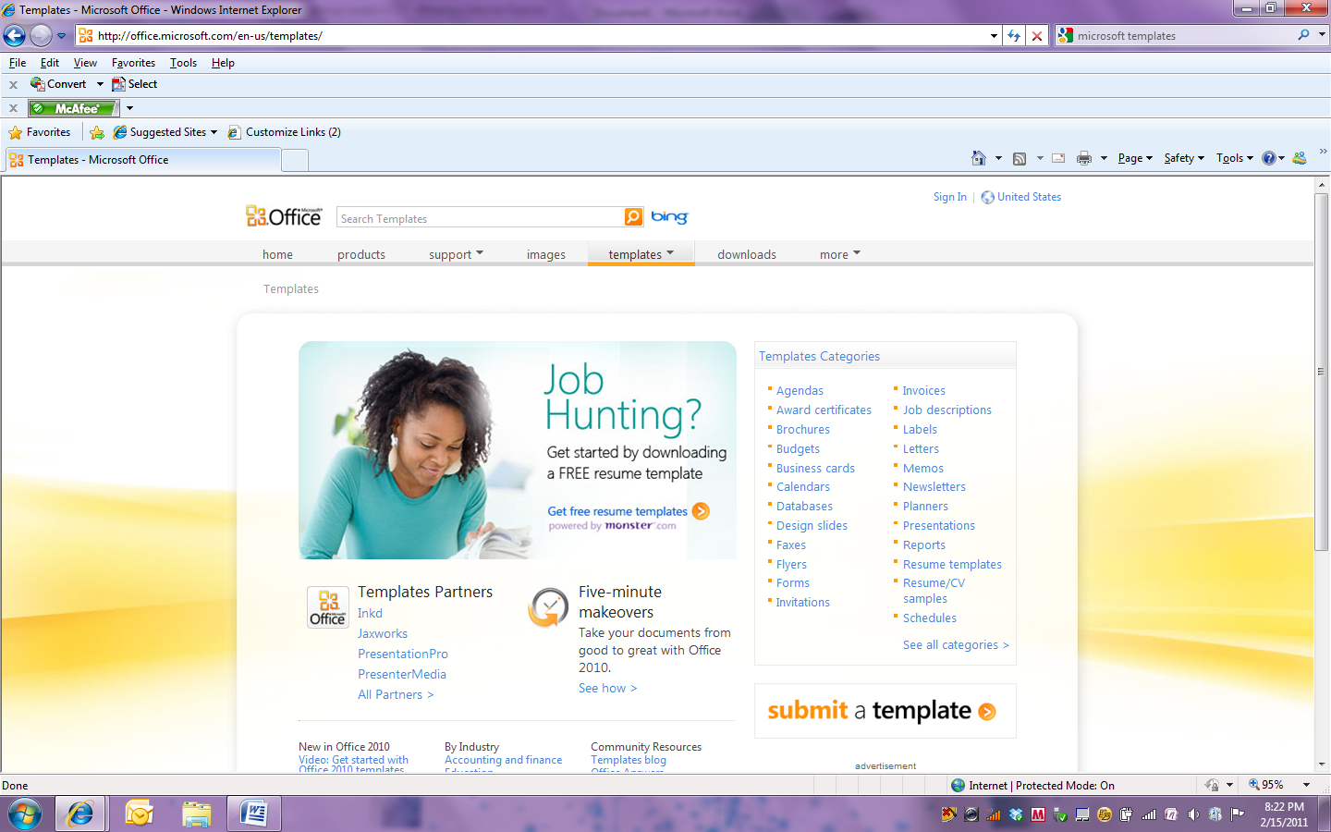

Use the Search feature to locate the type of template you are seeking.

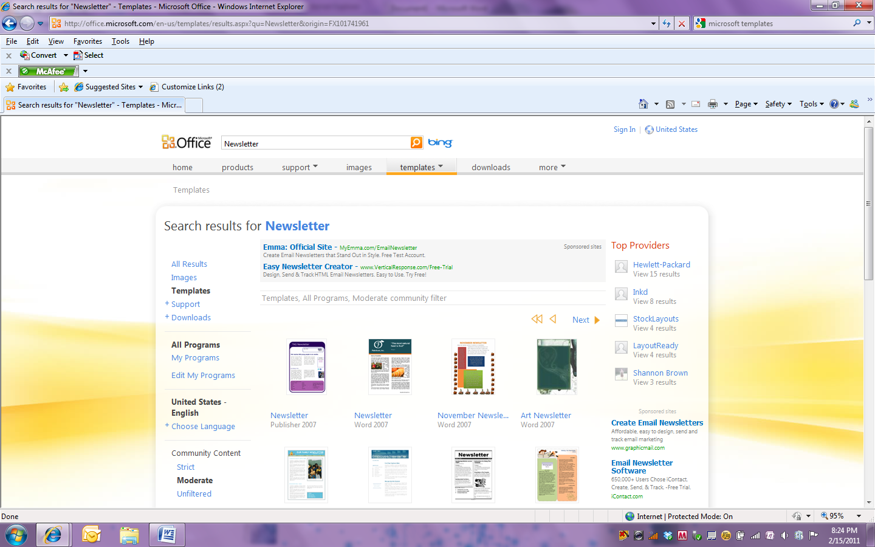

A search for Newsletters will return a screen with a variety of newsletter templates to select from. You should note that the newsletters are in multiple software formats (Word 2003, Word 2007, Word 2010, Publisher 2003, Publisher 2007 and Publisher 2010). You can reduce the formats displayed by editing the selected programs.

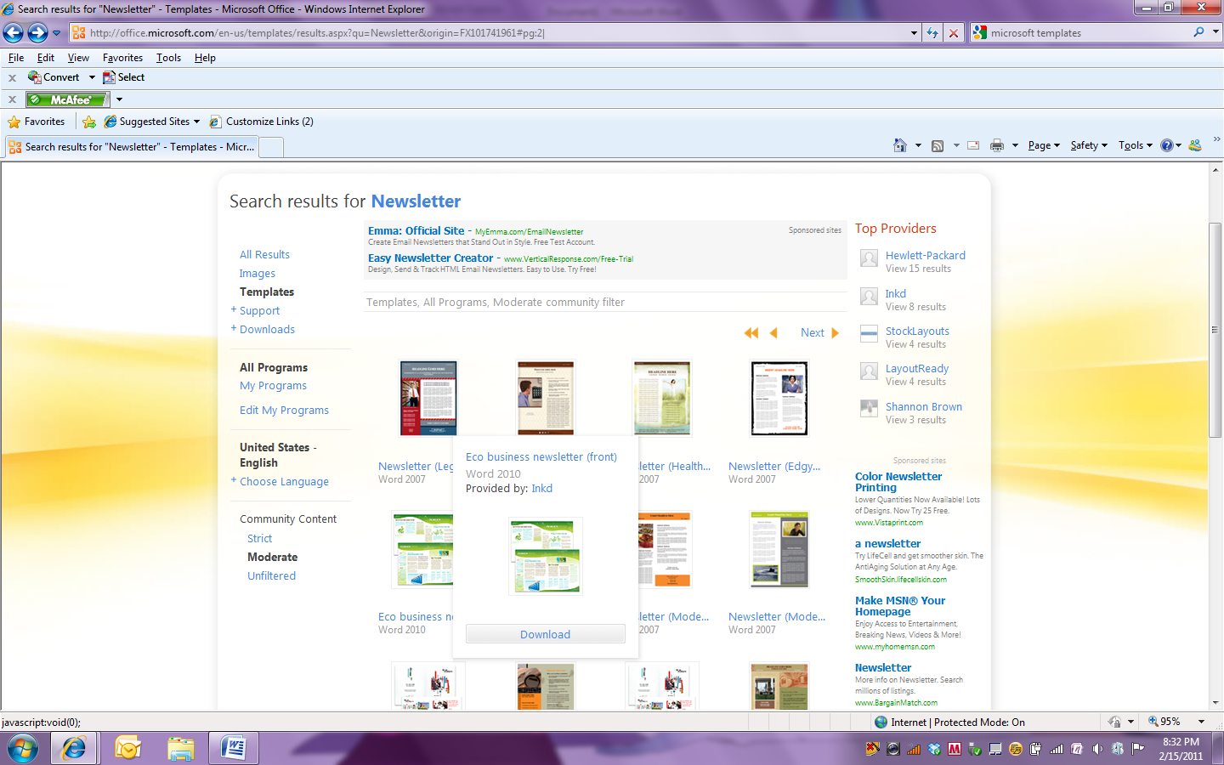

Place you mouse on the newsletter template you would like to download. You will get a pop-up window with a Download button. Click on Download.

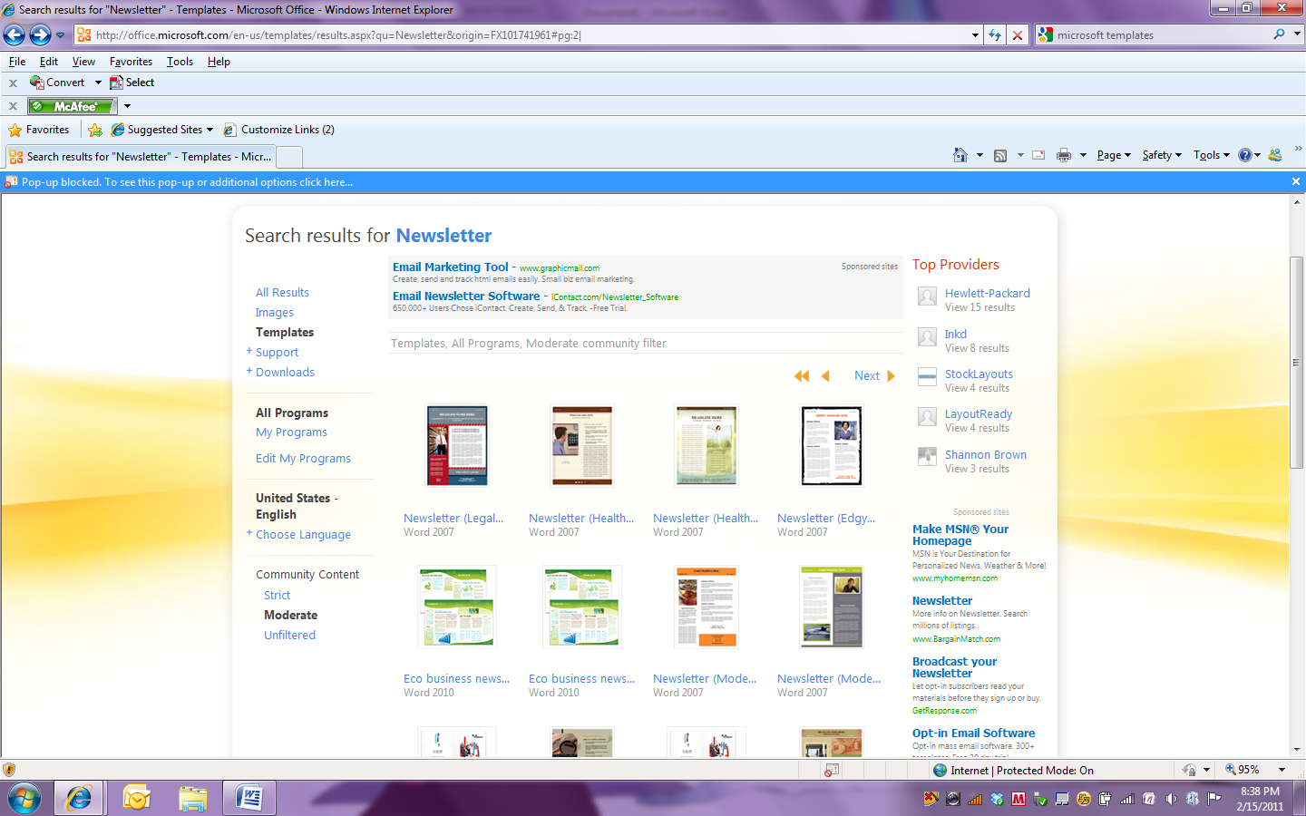

If you get a Pop-up blocked message. Click on the messages for additional options.

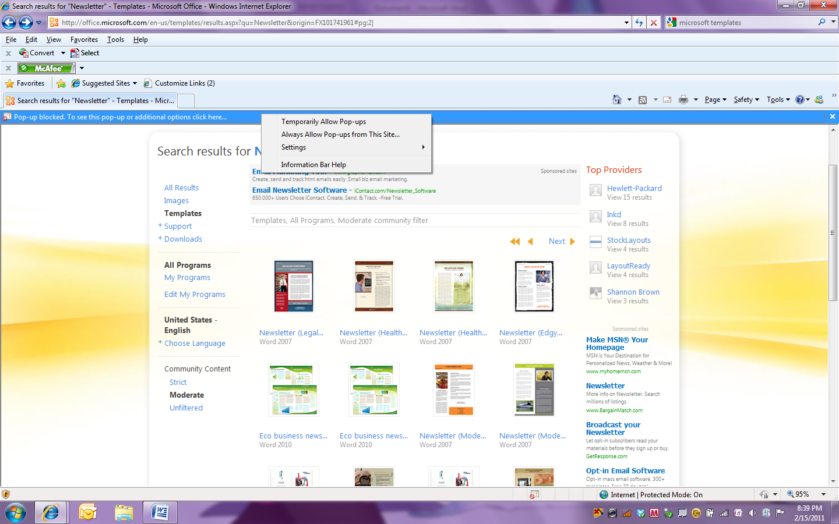Select Temporarily allow Pop-ups. Click on Download again.

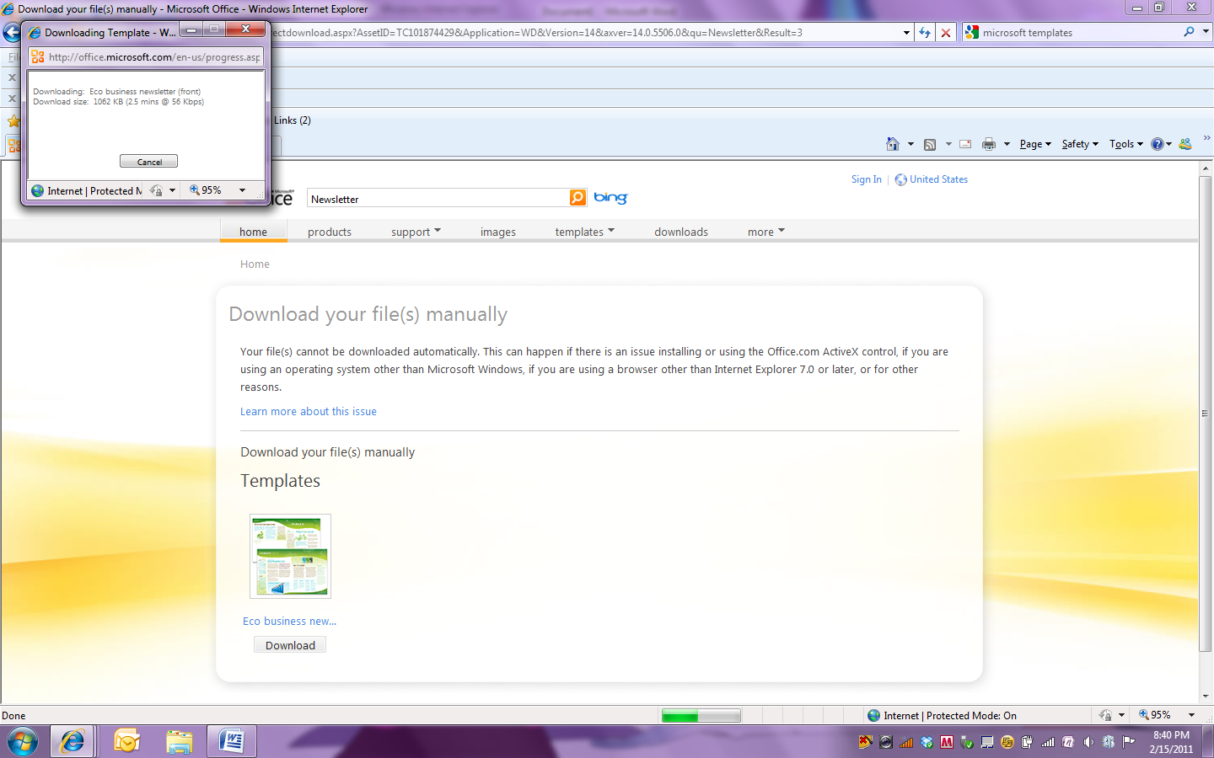

You will get a pop-up window indicating your template is being downloaded. If you are redirected to a Download your file(s) manually screen. Click on Download again.

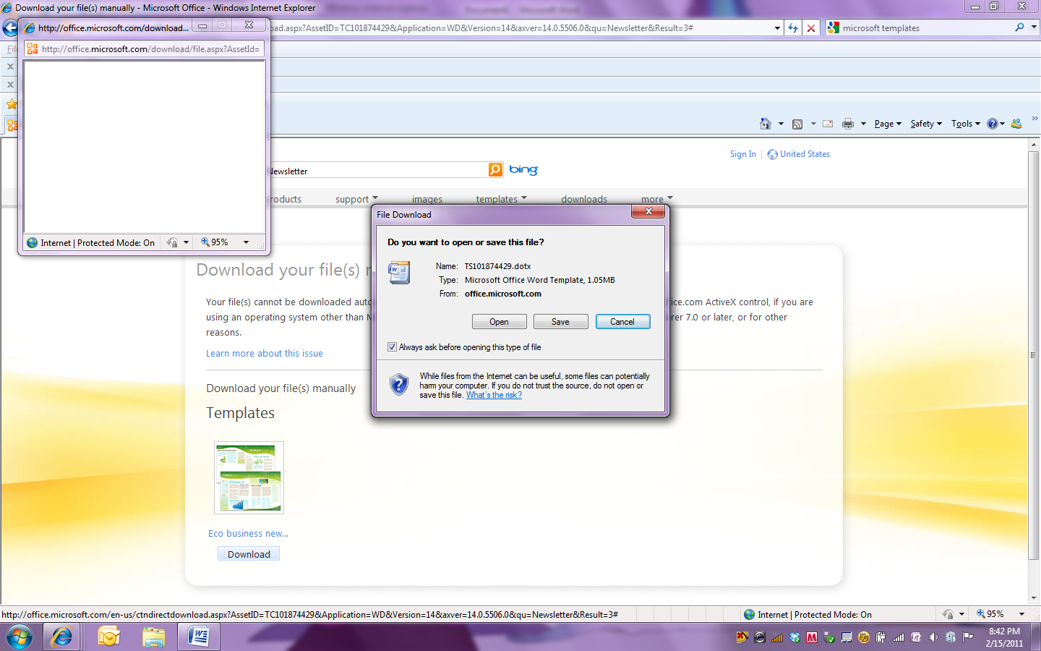

You will be prompted to open or save the template. If you chose Open you should immediately save your template for future use.