- After you’ve finished editing your final version, and it has already been saved again as a project (.wp3) on your computer…
(Remember that when it’s a .wp3, it is editable, but it can only be opened on a computer that already has the MS PhotoStory application installed on it. You will not turn in this file format for class credit, but don’t delete it – it is the version on which you can make corrections or changes.)

- You also need to convert it to a video file (.wmv) so that it can be viewed in Windows Media Player.

- The steps to convert it into a video file (.wmv):

While you have your digital story (the .wp3 version) open in the PhotoStory3 application, use the “next” button until you reach the “Save your story” screen.

- Select “Save your story for playback on your computer.
- Browse to select the destination folder where you will save it.
You can keep the same file name as the original .wp3 file.
Do not click the “Save Project” button this time.
- Click the “Next” button at the bottom right.
You will briefly see a new window with green bars moving on it – This signifies that it is converting it to a video, which will have a .wmv ending.
The .wmv version is the one that you turn in for credit.

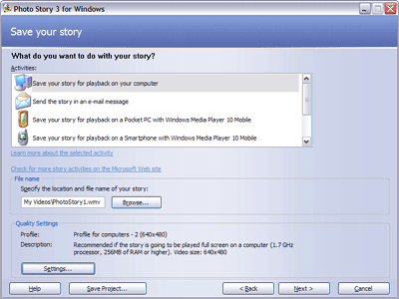
1
2
3
Do NOT click here this time

