Creating blank slides (solid color background) for use in PhotoStory. Page 1 of 3

PowerPoint is one of the easiest ways to obtain a custom-colored blank slide.
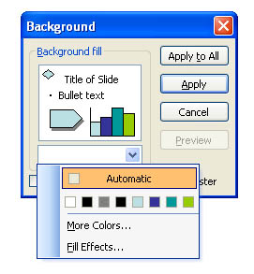
In PowerPoint 97-2003, to get a plain background:
1
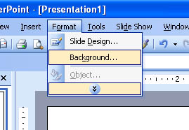

2

3

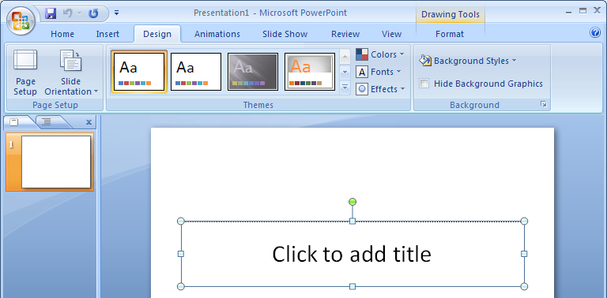
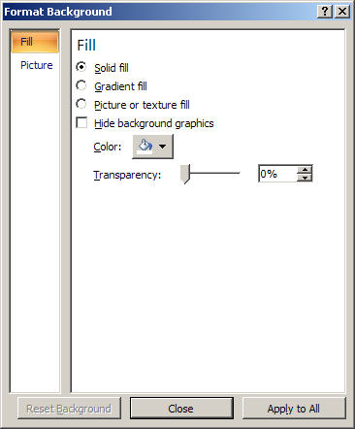
In PowerPoint 2007or 2010, to get a plain background:
1
2
3
4
5
6
Creating blank slides (solid color background) for use in PhotoStory. Page 1 of 3

To export the slide as a graphic in PowerPoint 2007-2010:

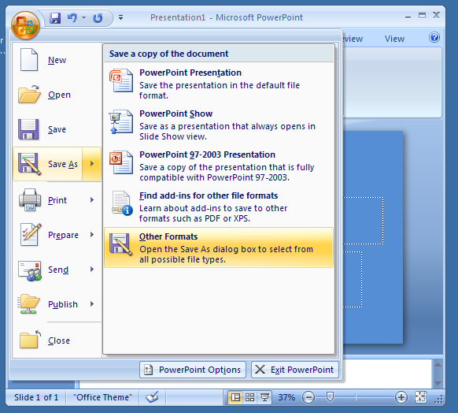
1

2

3

(4) Browse to change the destination into the correct folder
(5) Rename the file (short, meaningful, no spaces, such as: blue_blank)
(6) Choose PNG as the graphic format
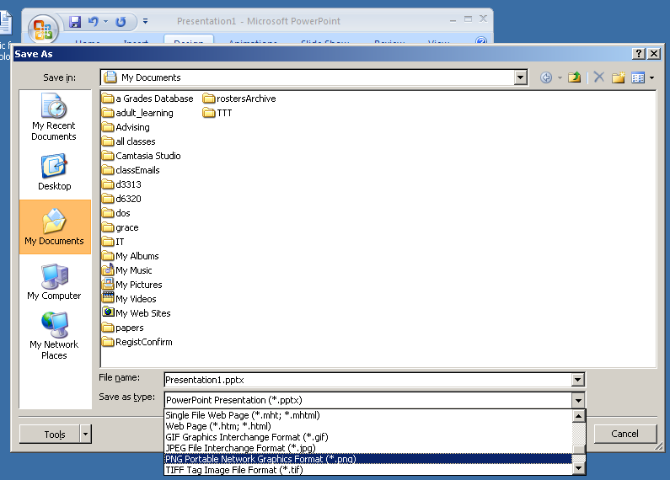
(6) Click: Save
4
5
6

To export the slide as a graphic in PowerPoint 97-2003:

- Go to File/Save as
- In PowerPoint 97-2003, when you get the “Save as” dialog box, look at the lower portion of the box… change the “save as type:” by clicking on the down arrow and scrolling down to PNG (Portable Network Graphic.)
- Give it a short meaningful file name with no spaces (like “blue_blank”) and select the folder on your computer where you will save it… probably in the same folder with your other images for this project.

